AWS Task-3

**AWS Task-3**

**Task Description:**

1. Create a S3 bucket, with no public access and upload files to the bucket & view the logs using cloudwatch for the uploaded files.
2. Launch two ec2-instances and connect it to a application load balancer, where the output traffic from the server must be an load balancer IP address

**Techstacks needs to be used :**

* AWS S3
* AWS EC2
* AWS LoadBalancer

1. Create a S3 bucket, with no public access and upload files to the bucket & view the logs using cloudwatch for the uploaded files.

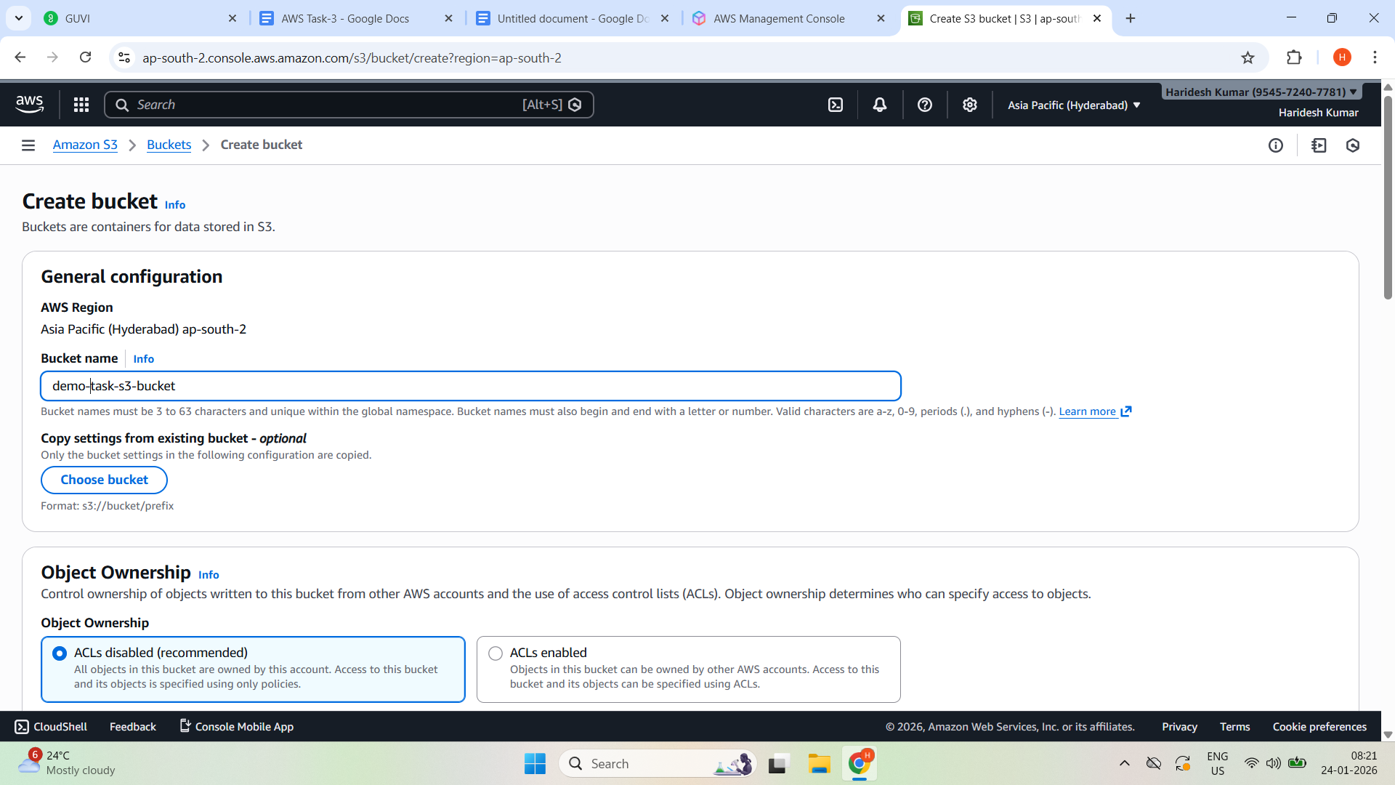

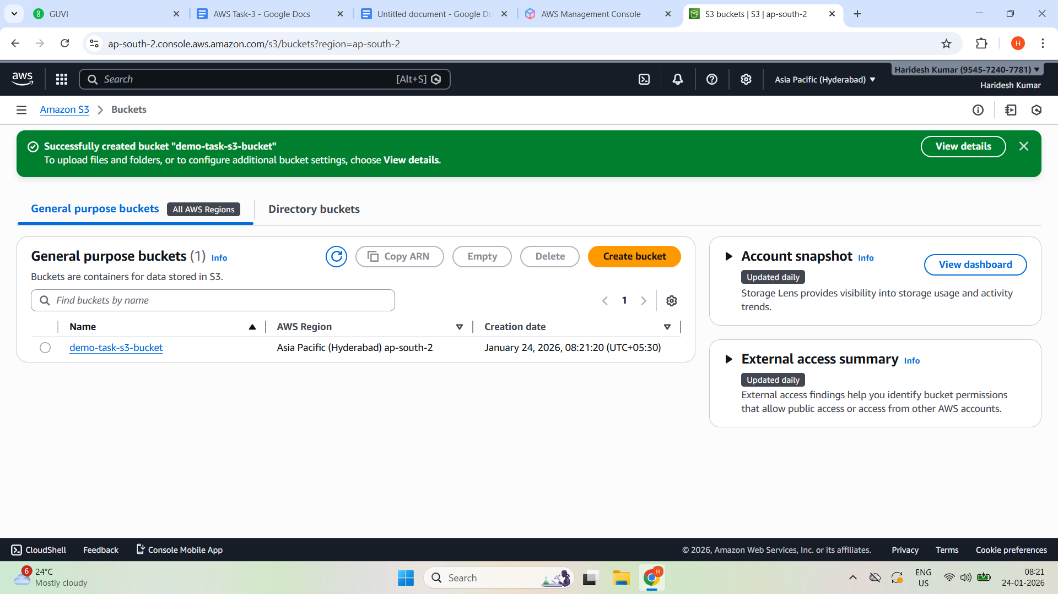

Created a s3 bucket

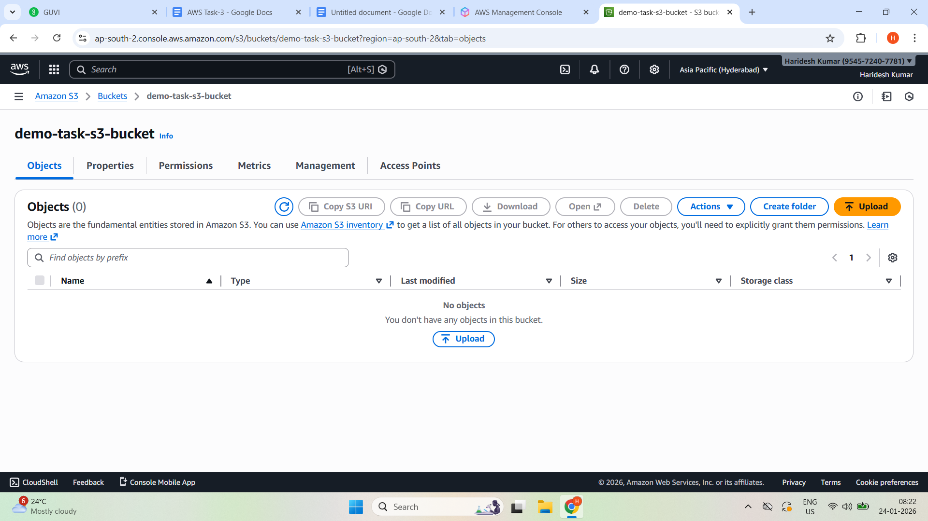

Upload Files to s3

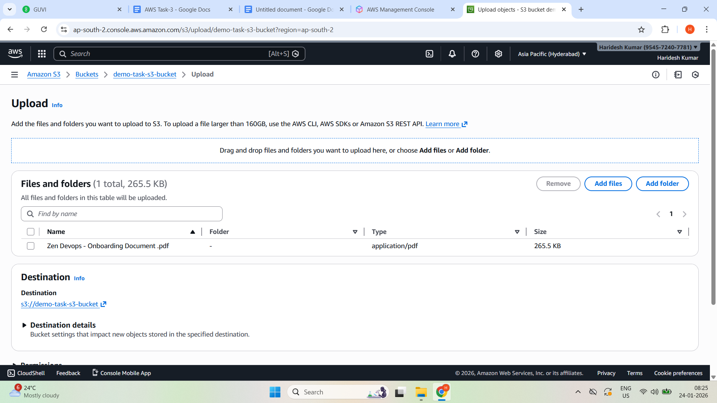

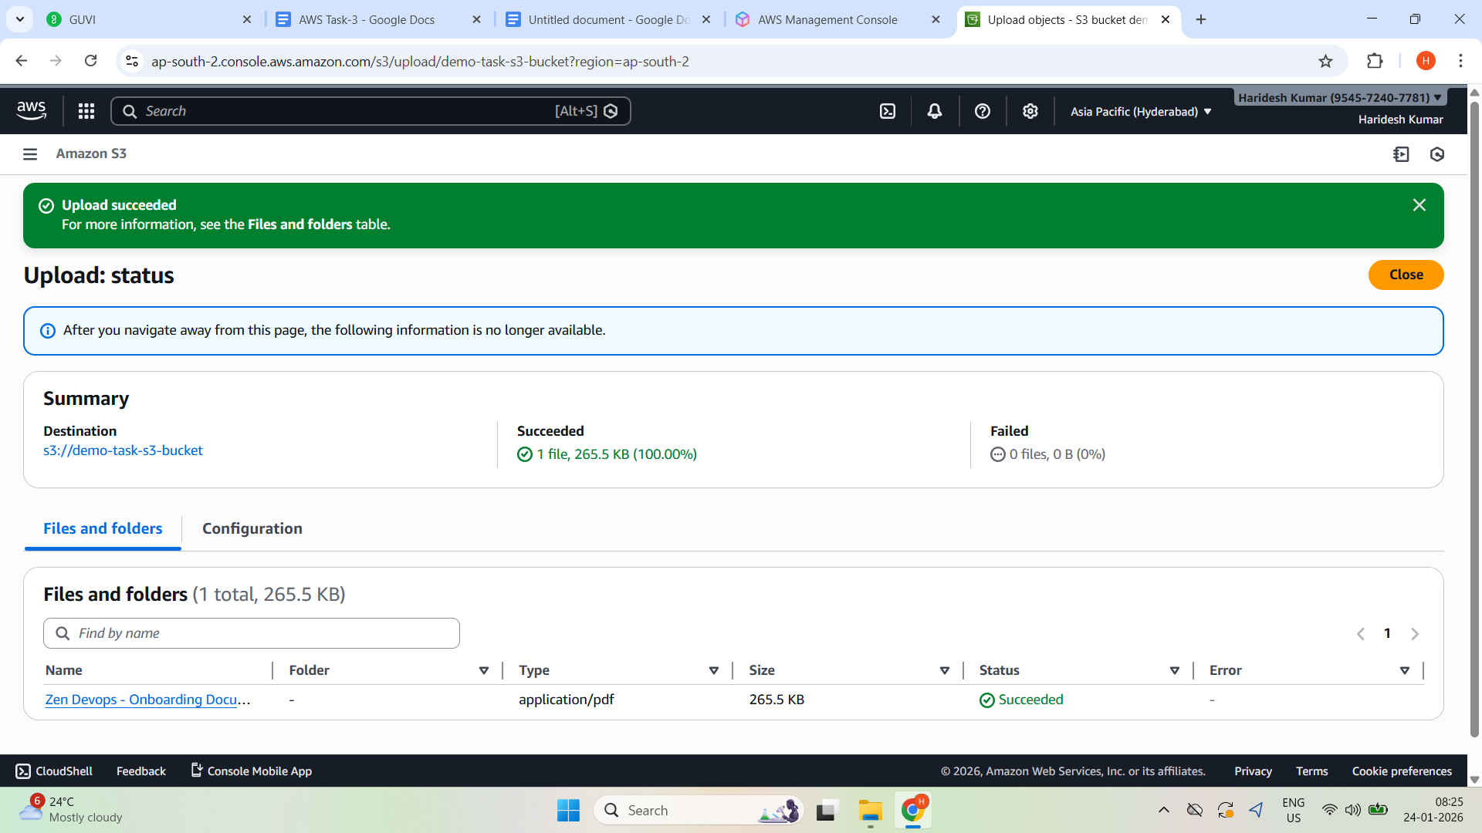

Enable S3 Server Access

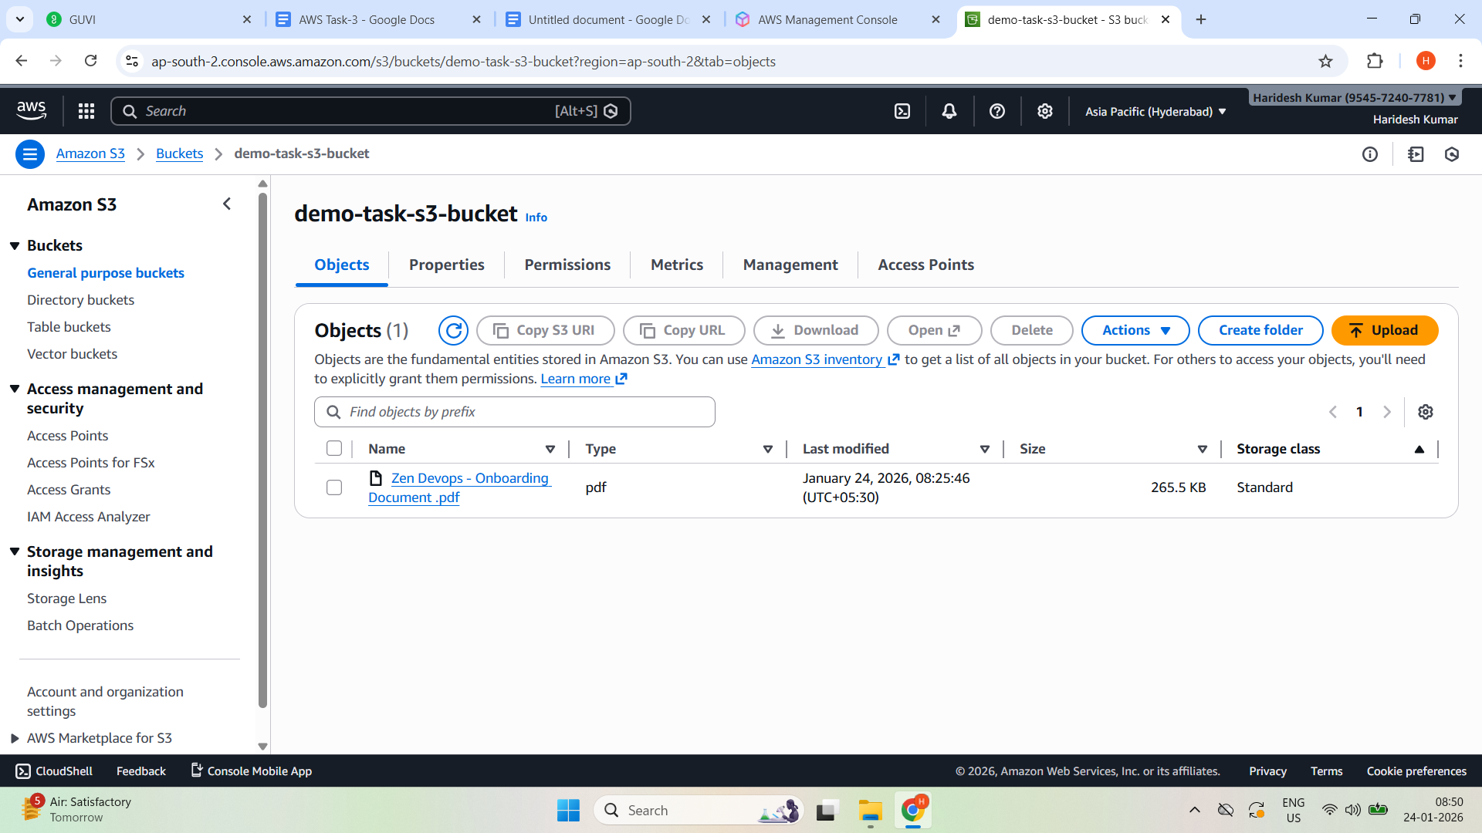

Properties

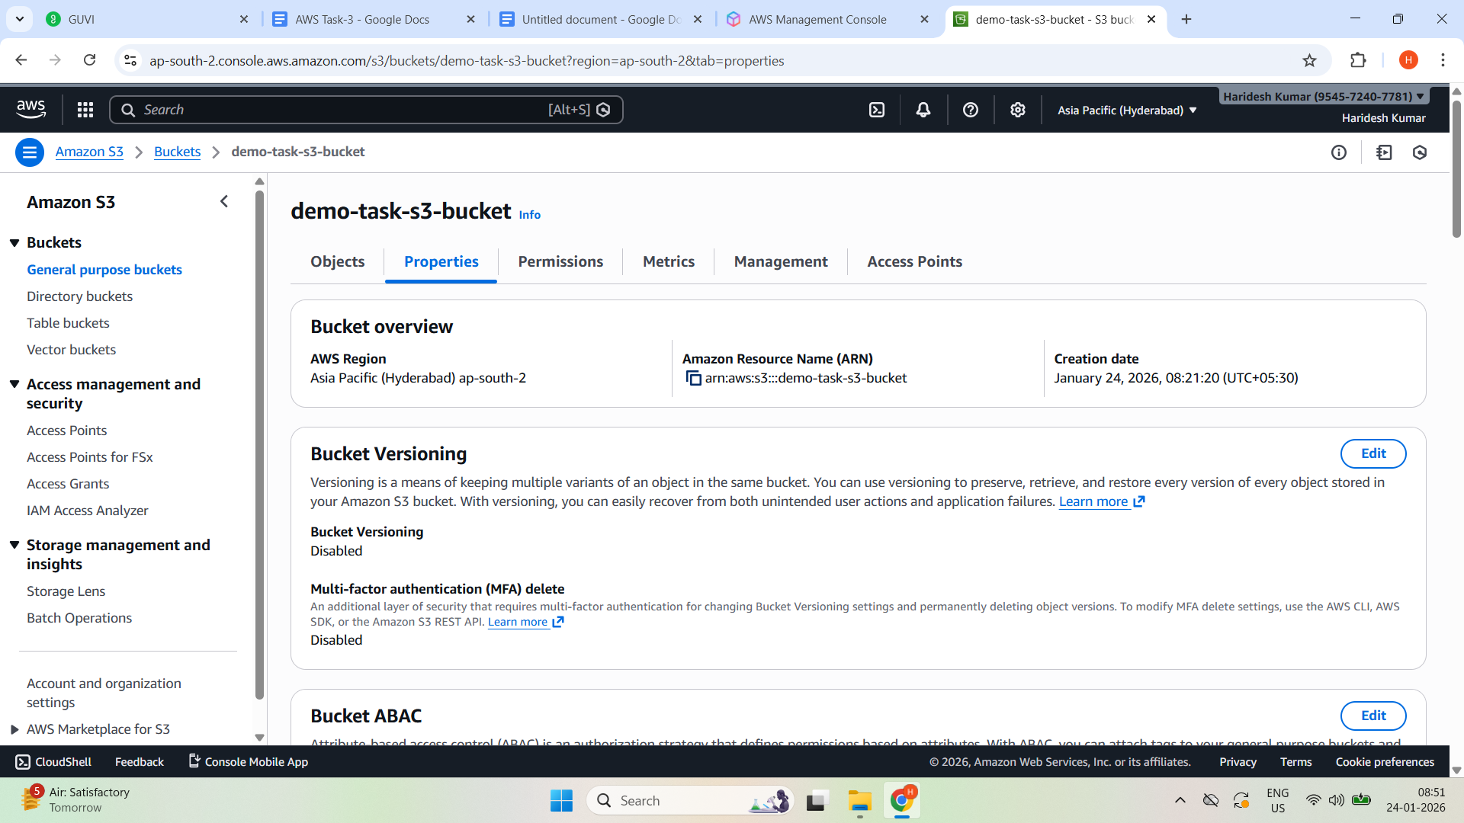

**Server access logging → Edit → Enable —> Destination→ save changes**

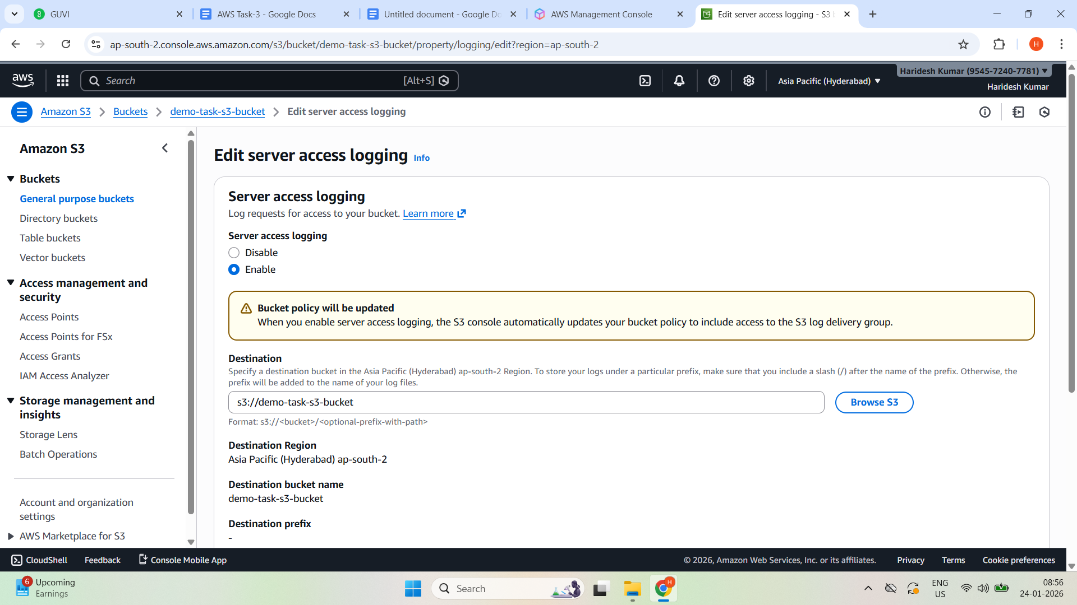

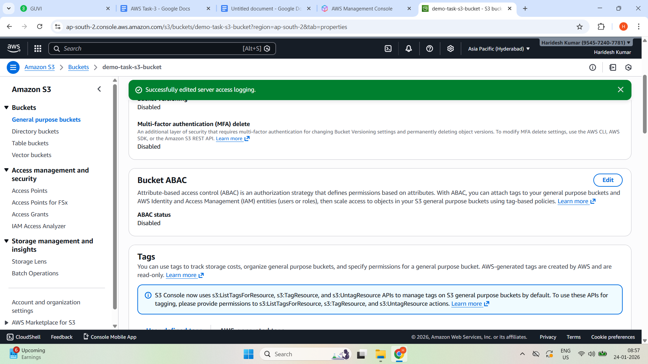

**Send s3 logs to Cloud Watch**

**CloudTrail → Create Trail**

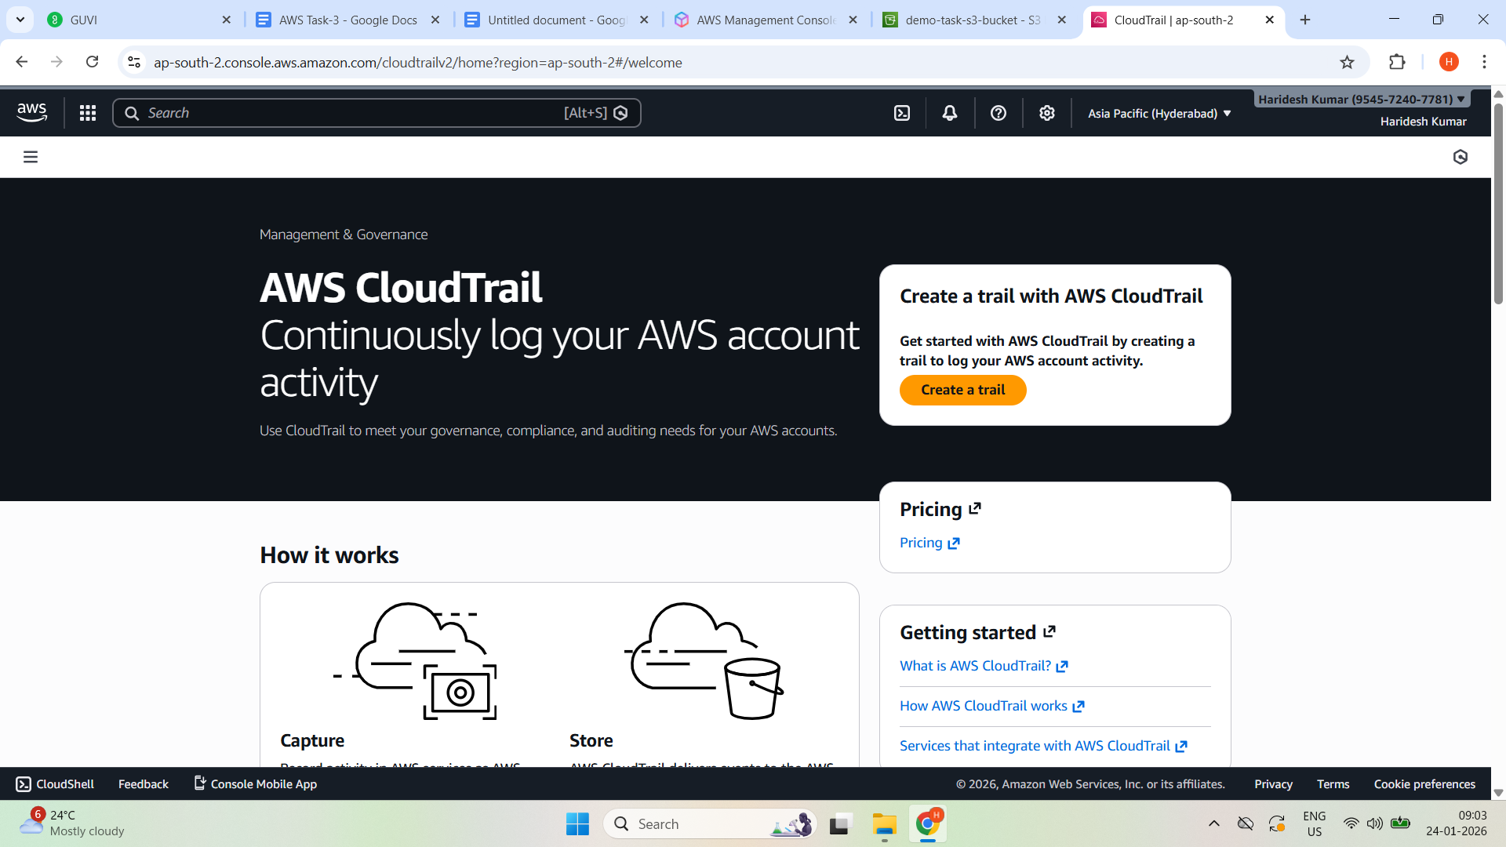

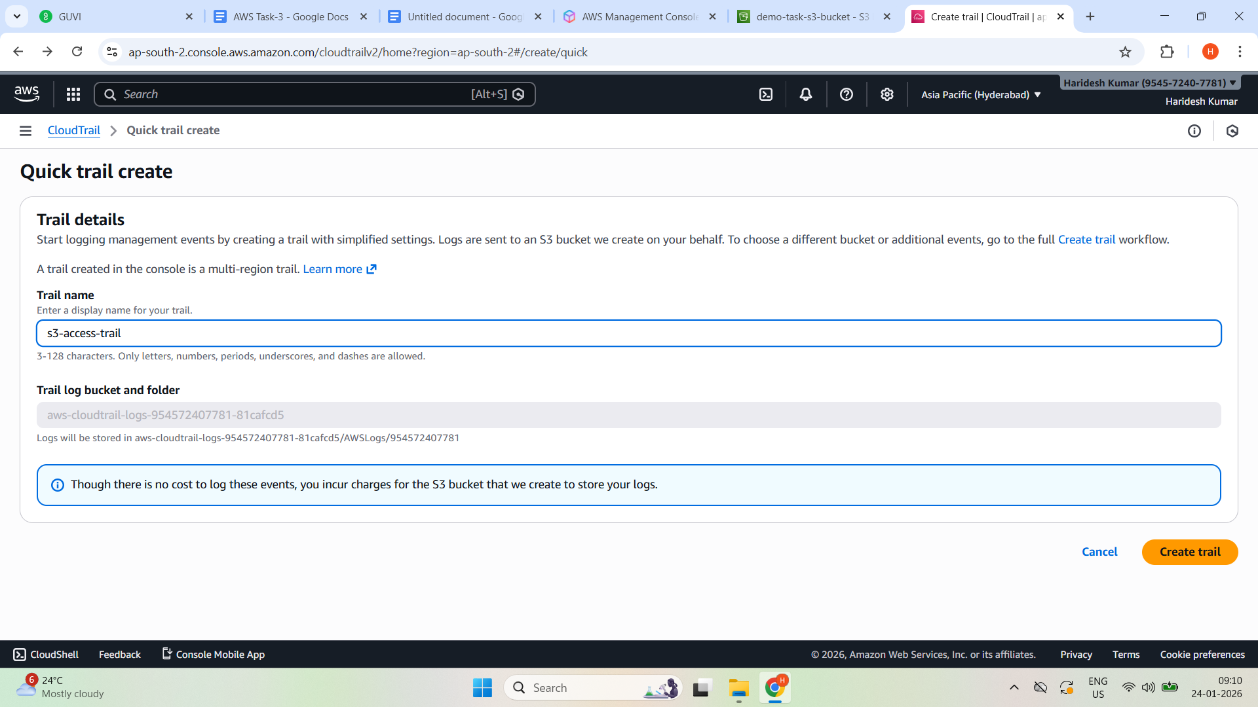

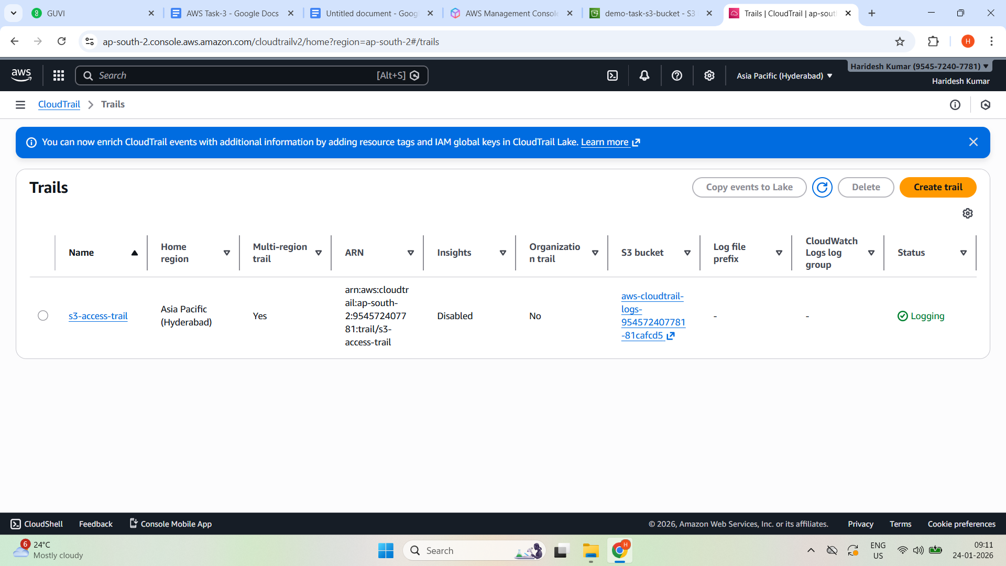

**Enabled Cloud watch log**

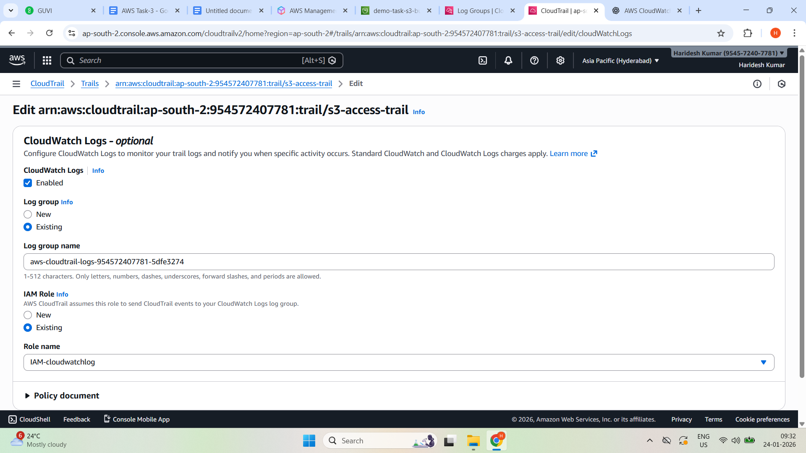

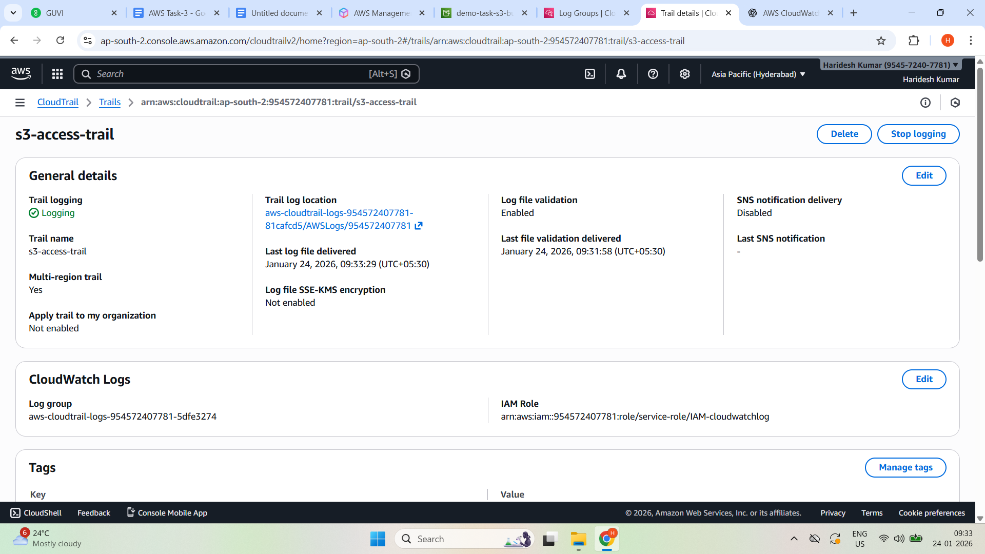

**Go to CloudWatch —-> Logs —--Log groups**

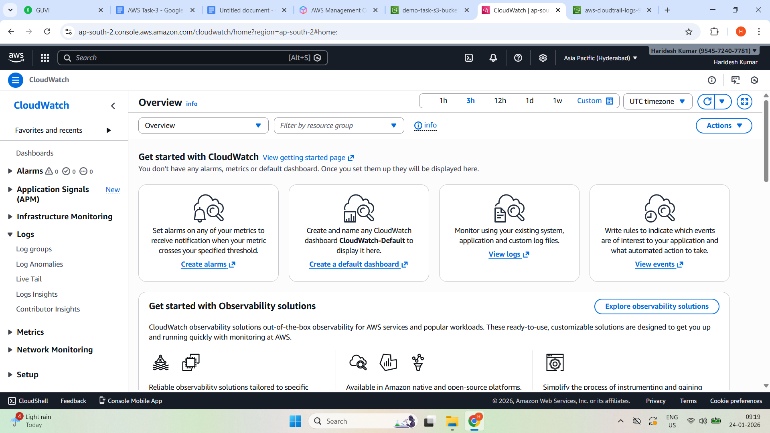

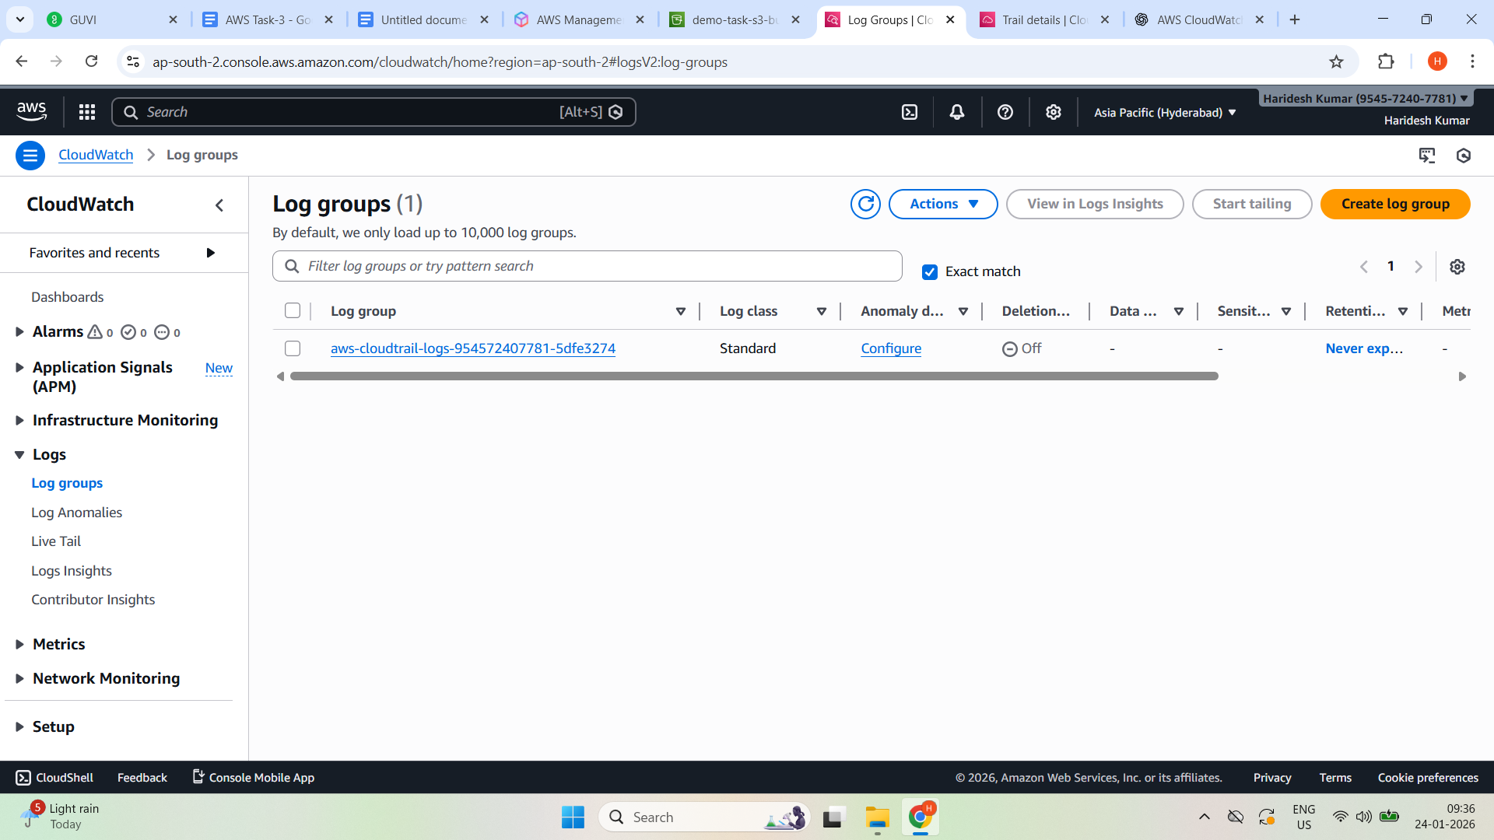

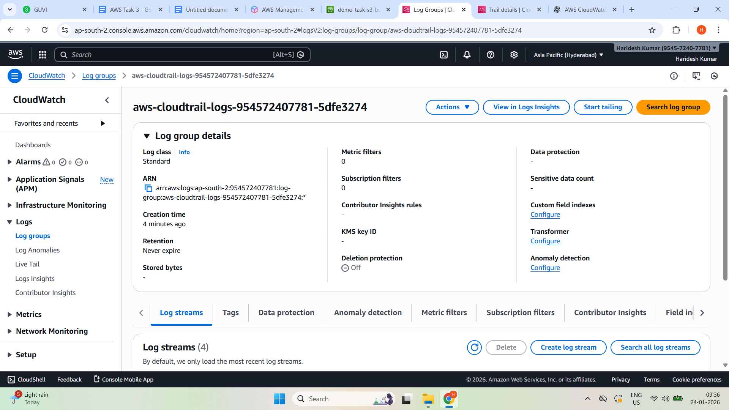

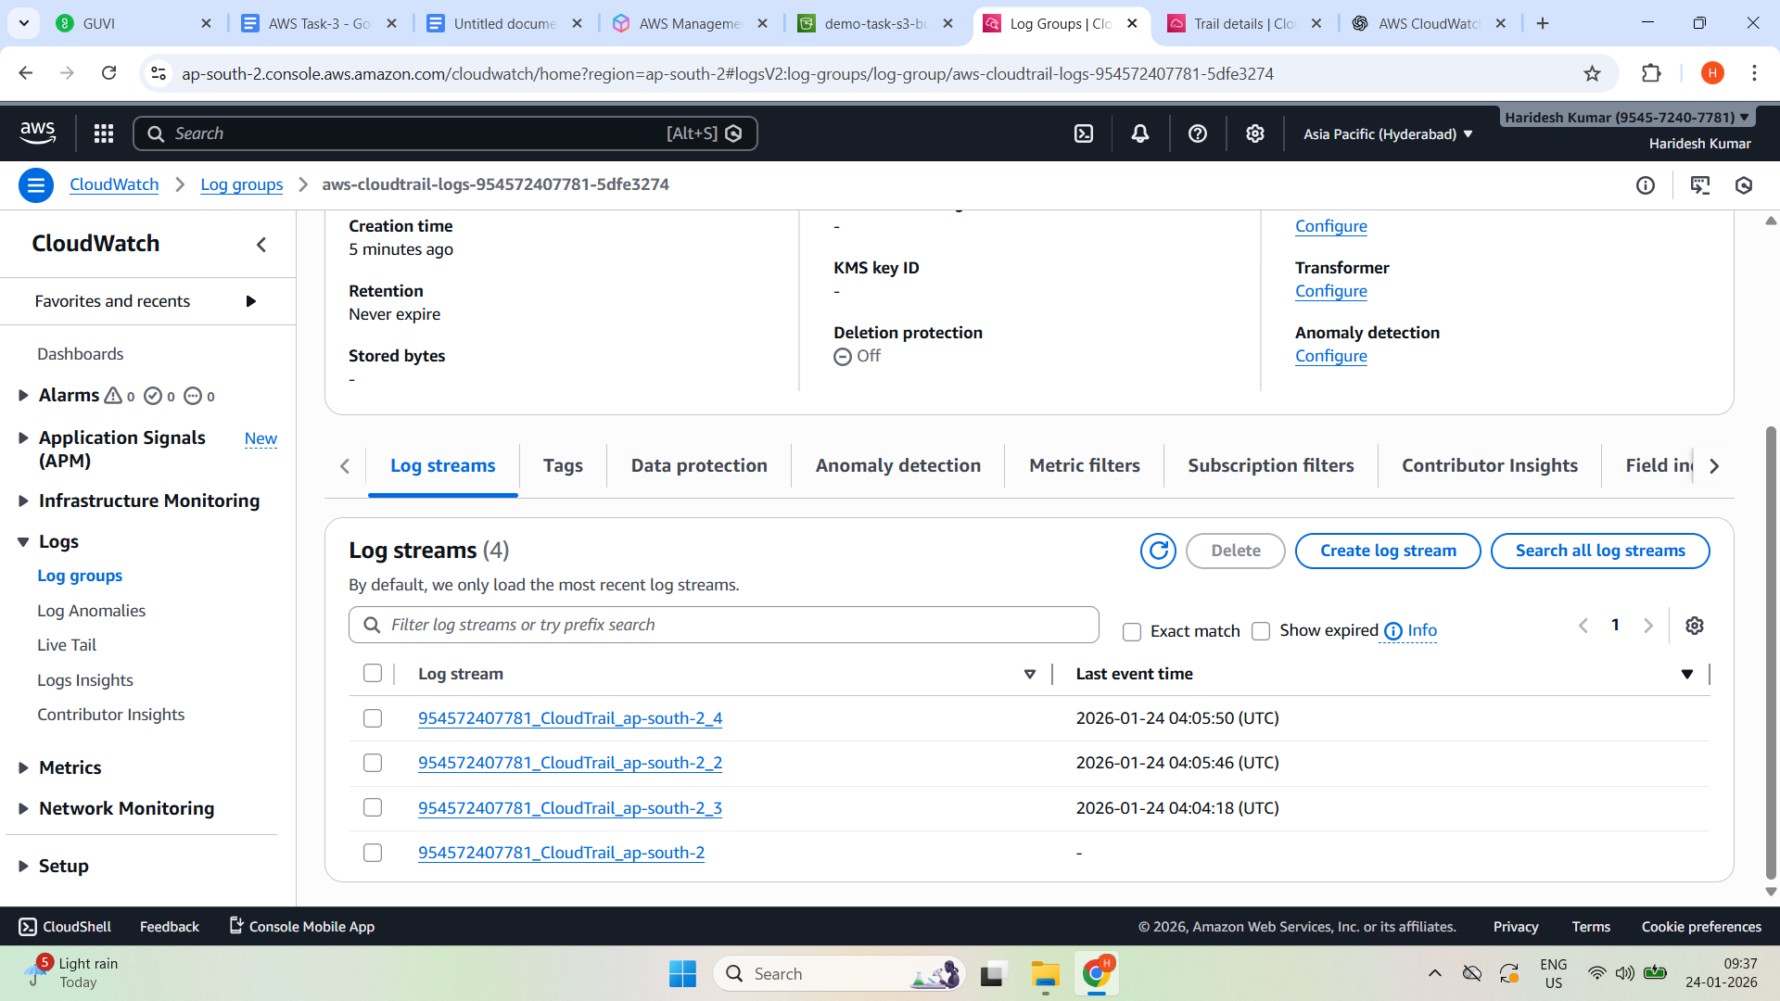

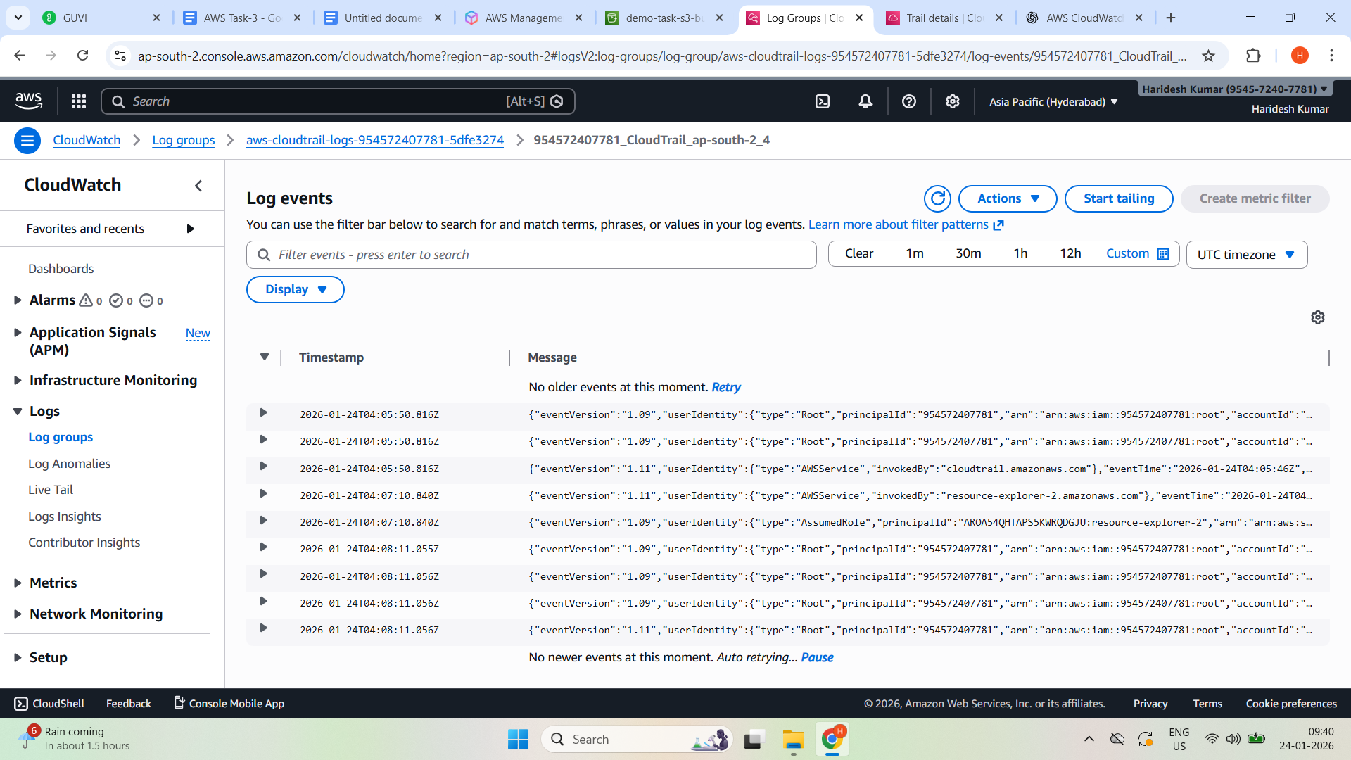

**—----------------------------------------------------------------------**

1. Launch two ec2-instances and connect it to an application load balancer, where the output traffic from the server must be an load balancer IP address

Launched two EC2 instances

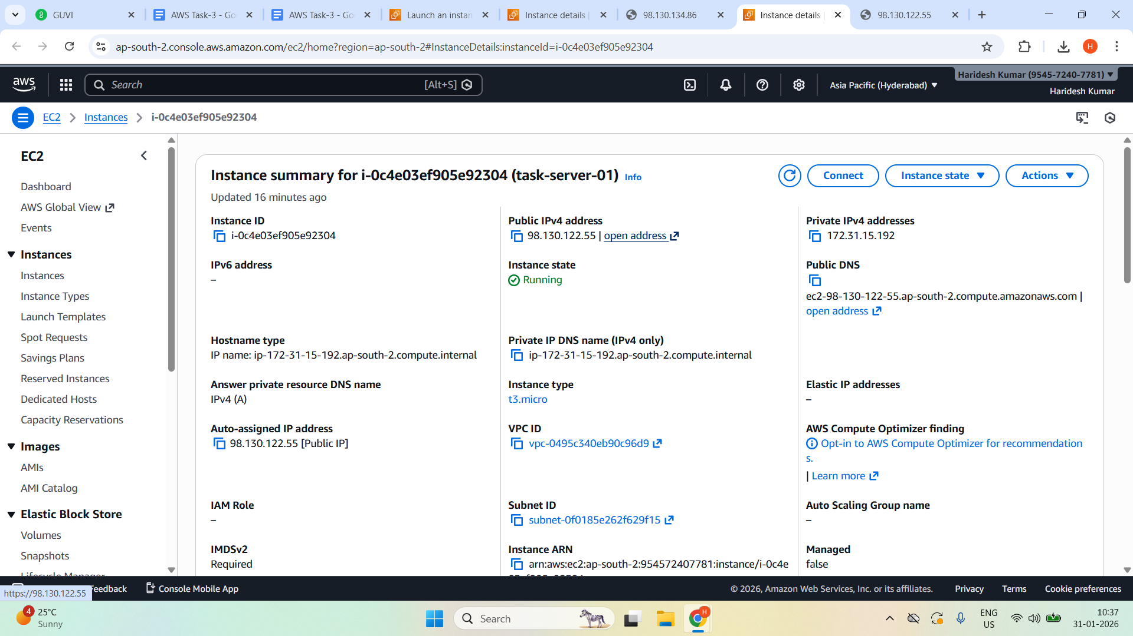

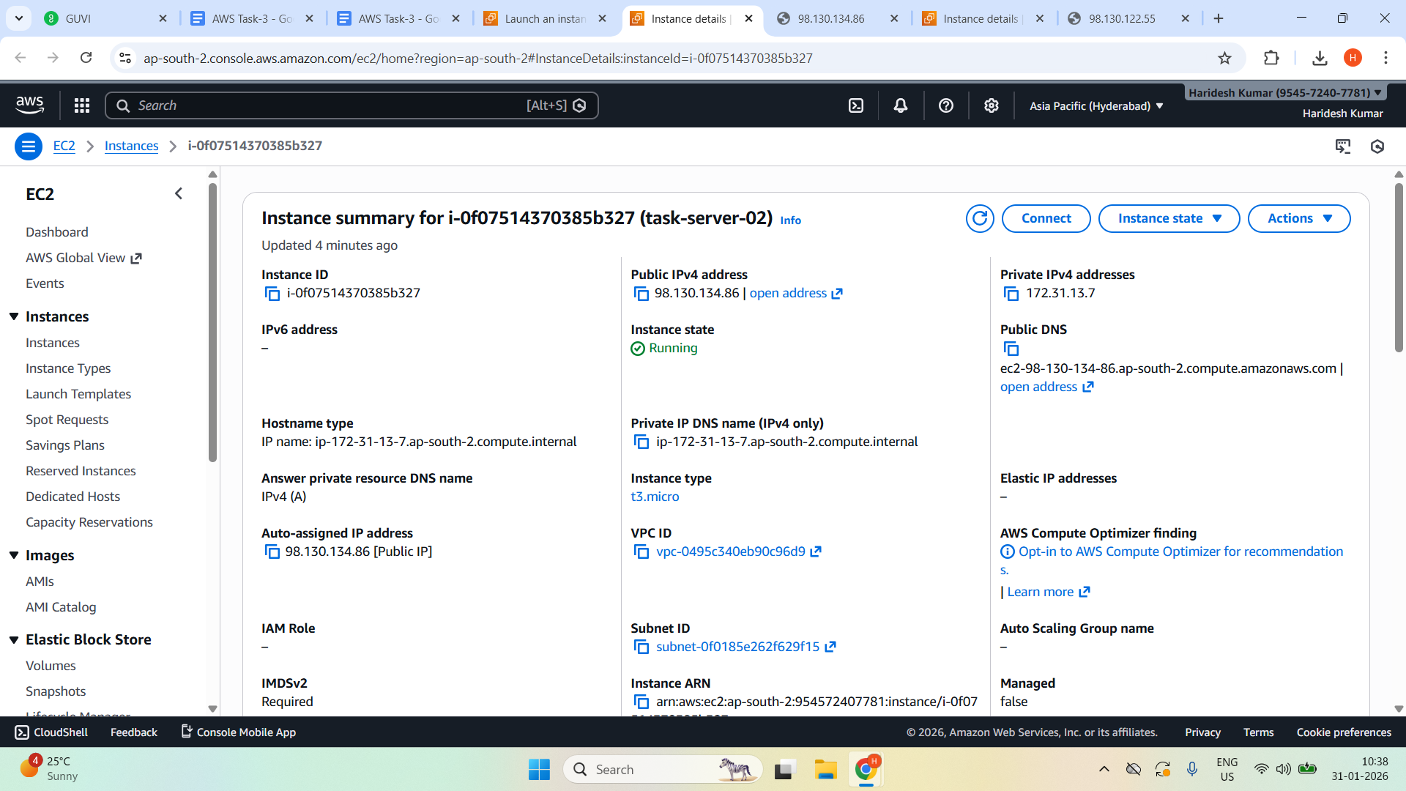

## **Verify EC2 instances**

Copy the **Public IPv4 address** of each instance and open the IP in a browser.

Confirm the Apache test page loads successfully  
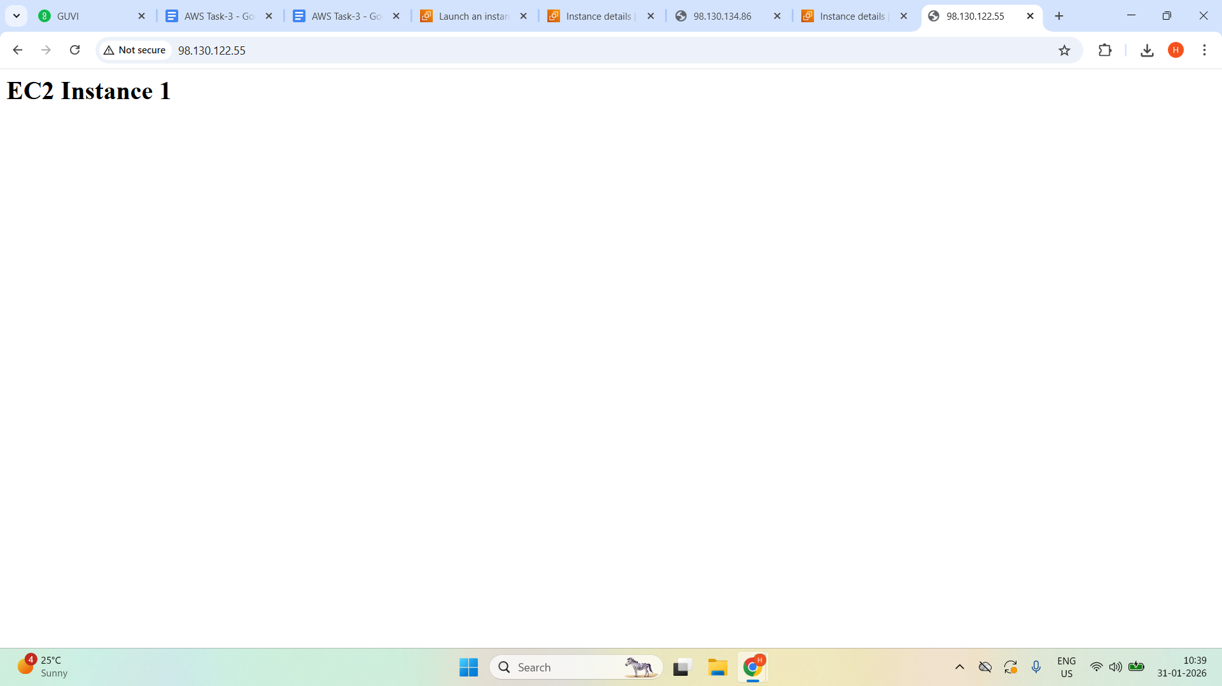

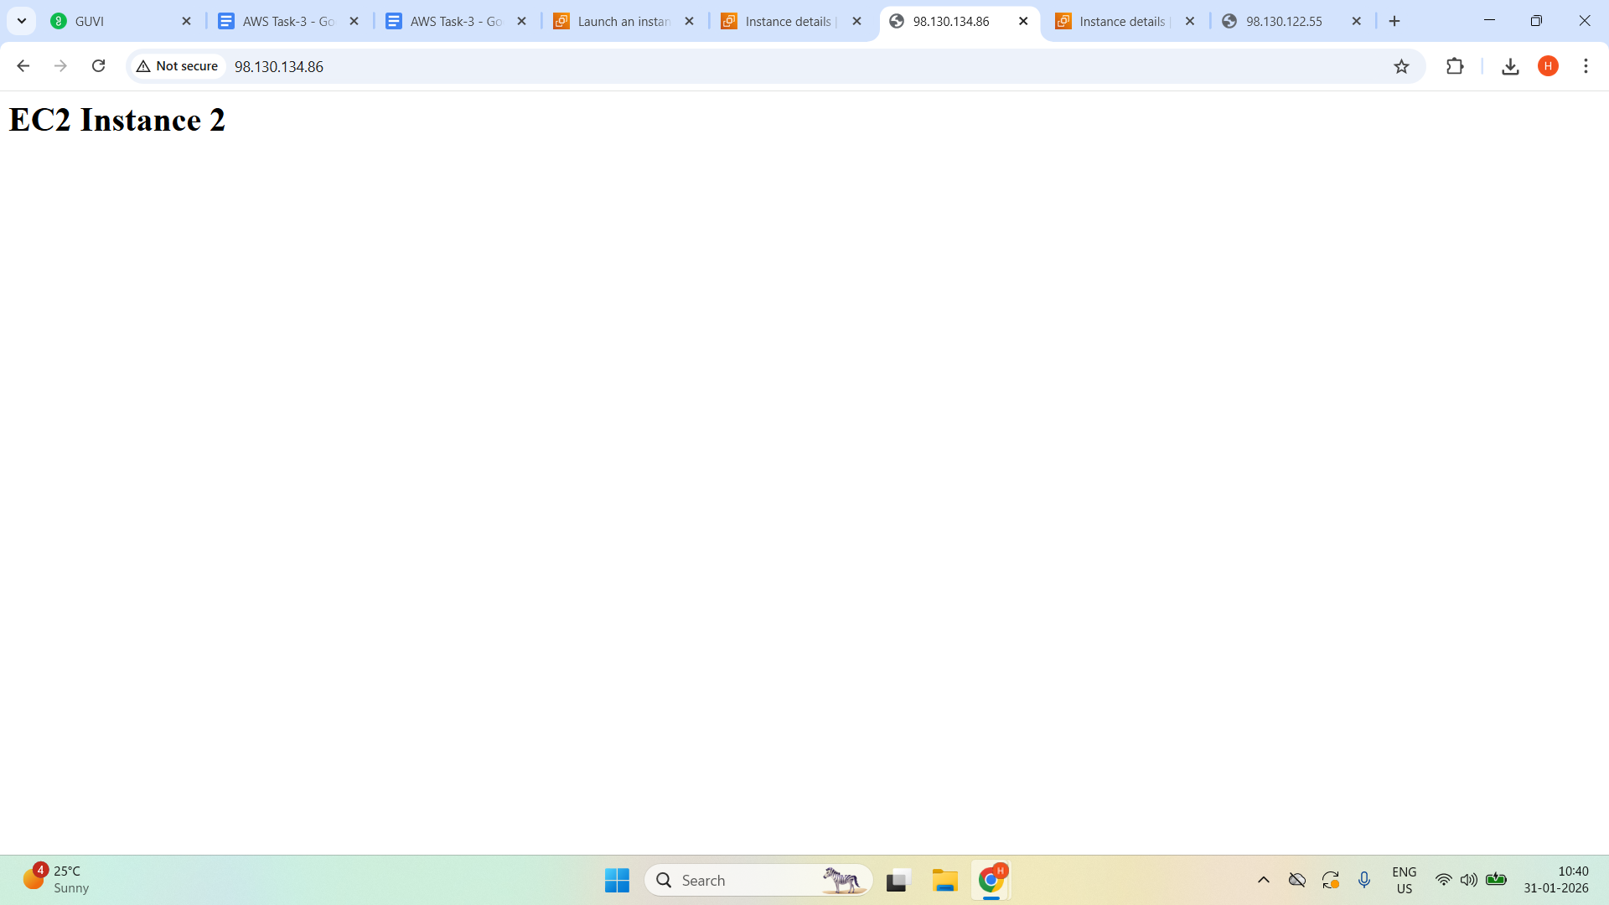

Create Target groups

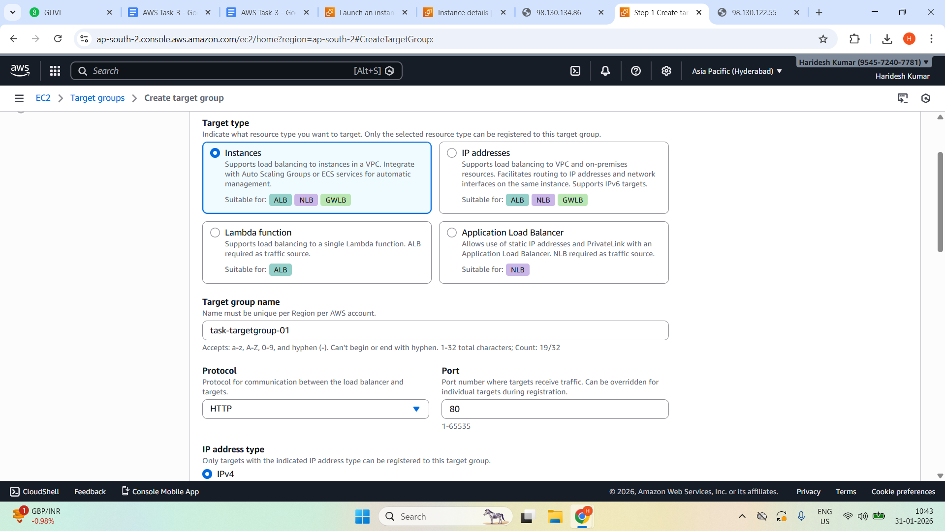

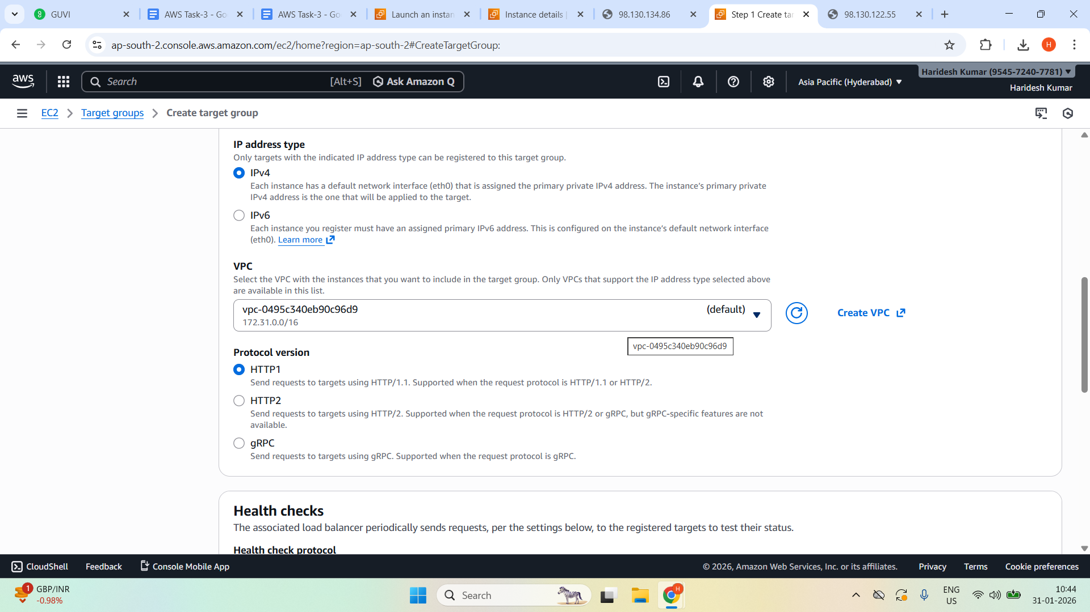

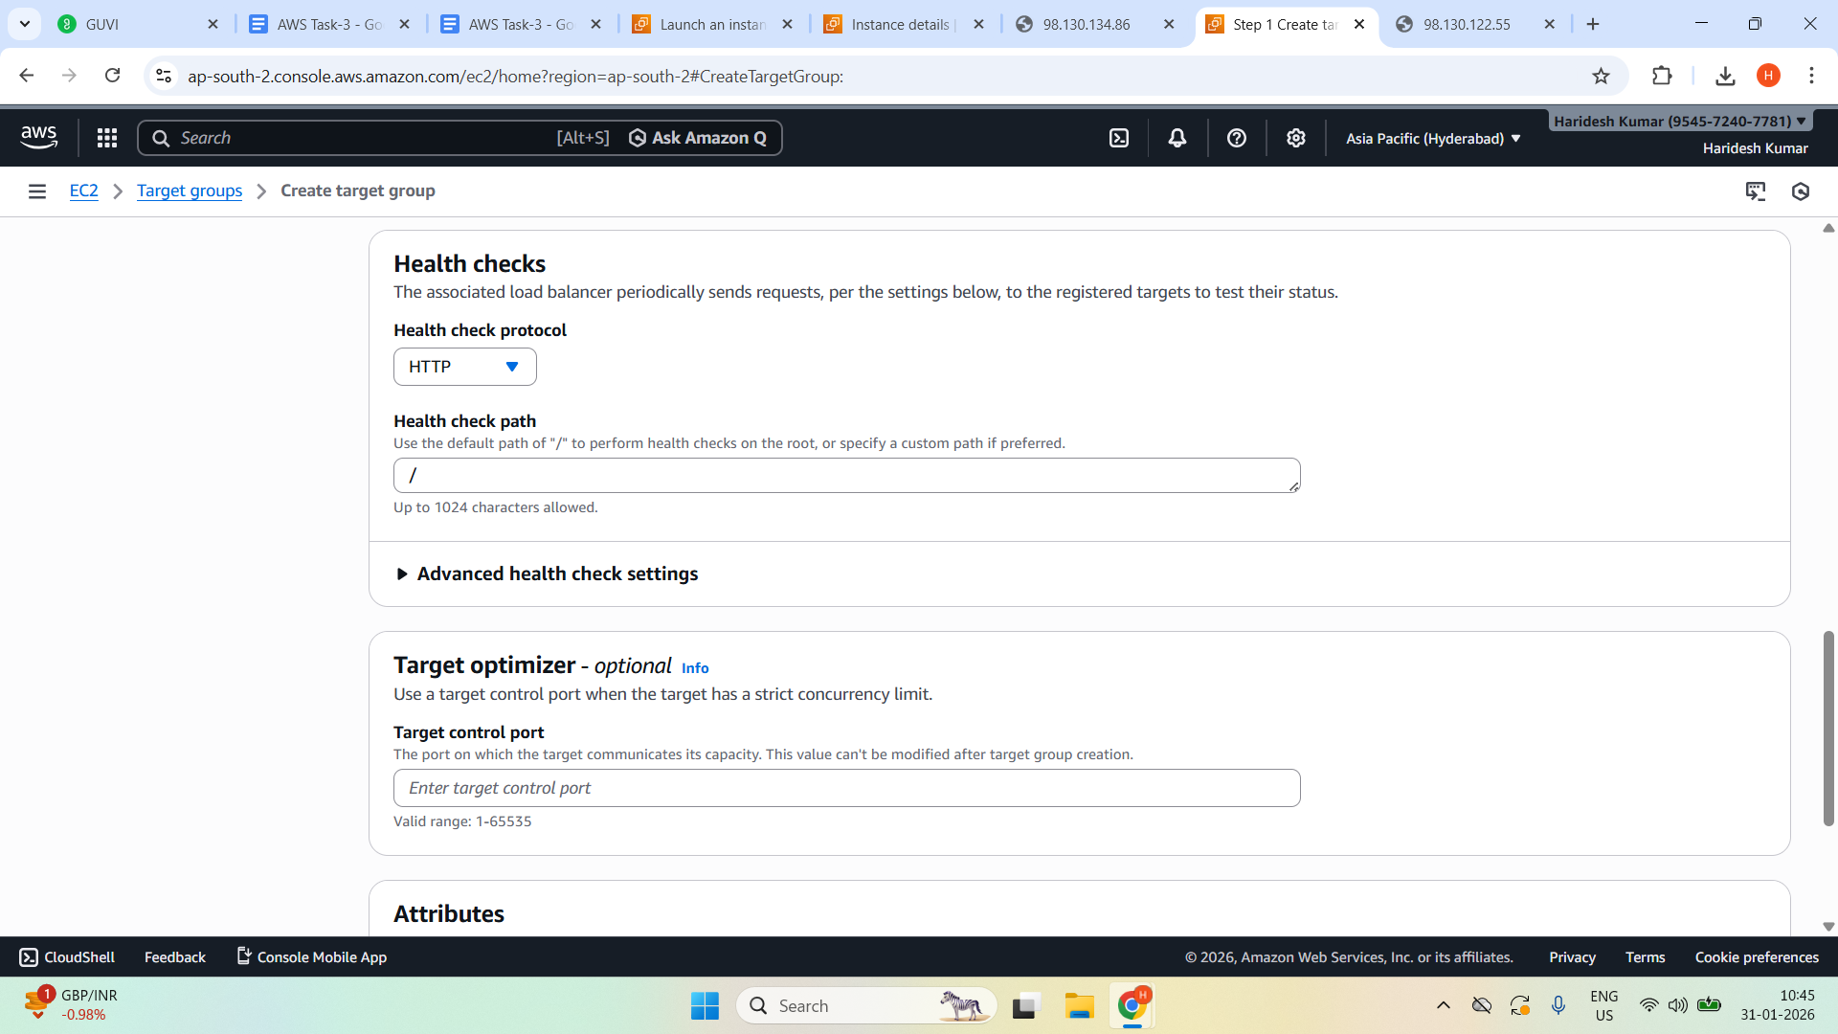

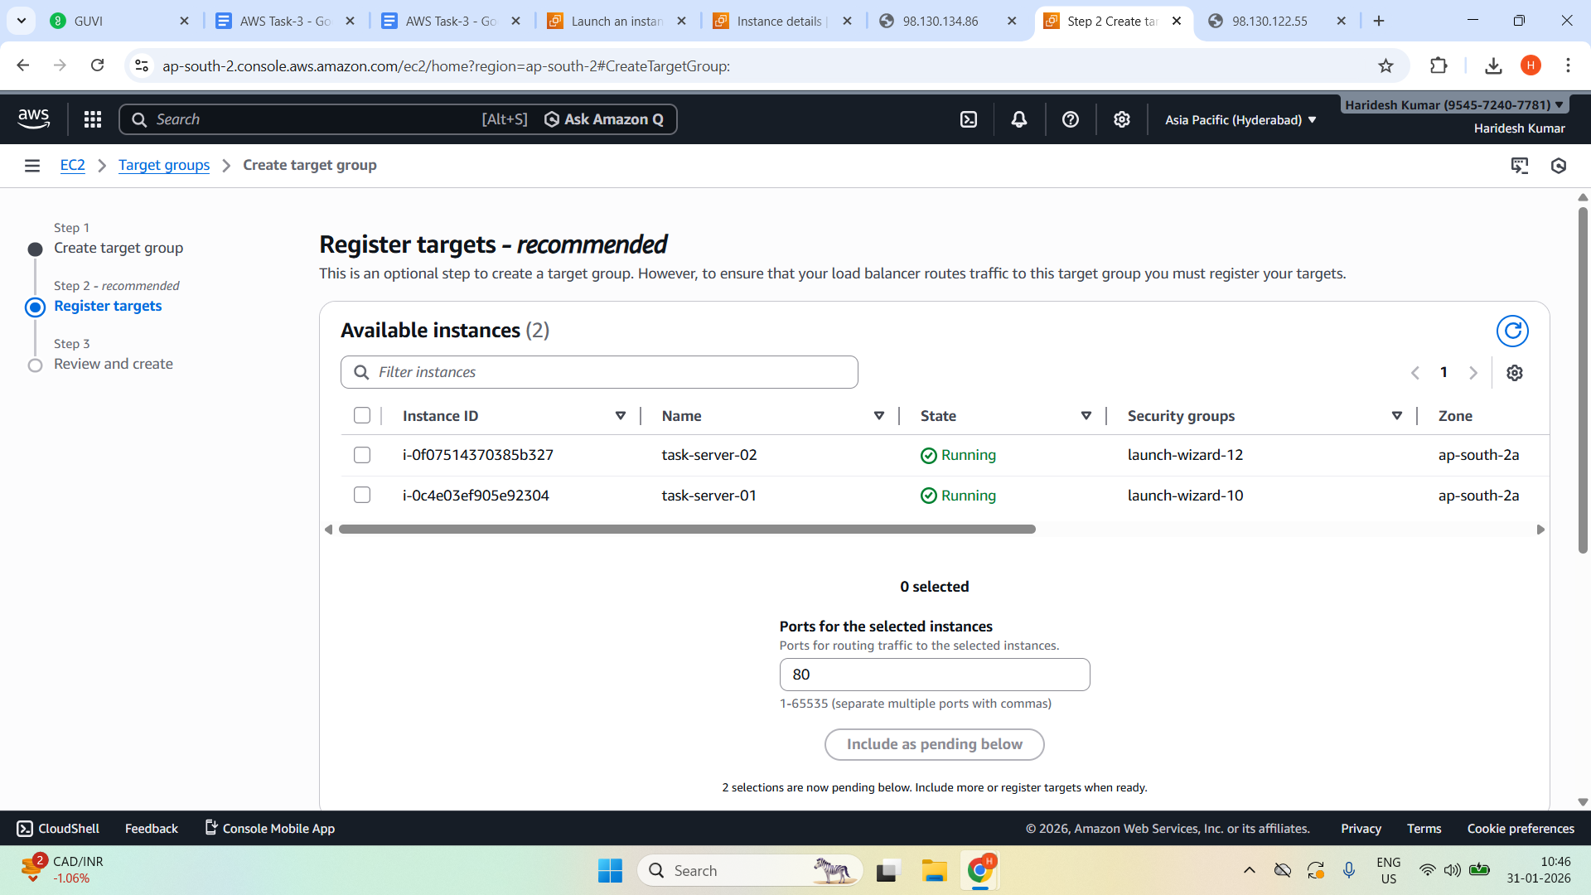

Register EC2 Instances in the target groups

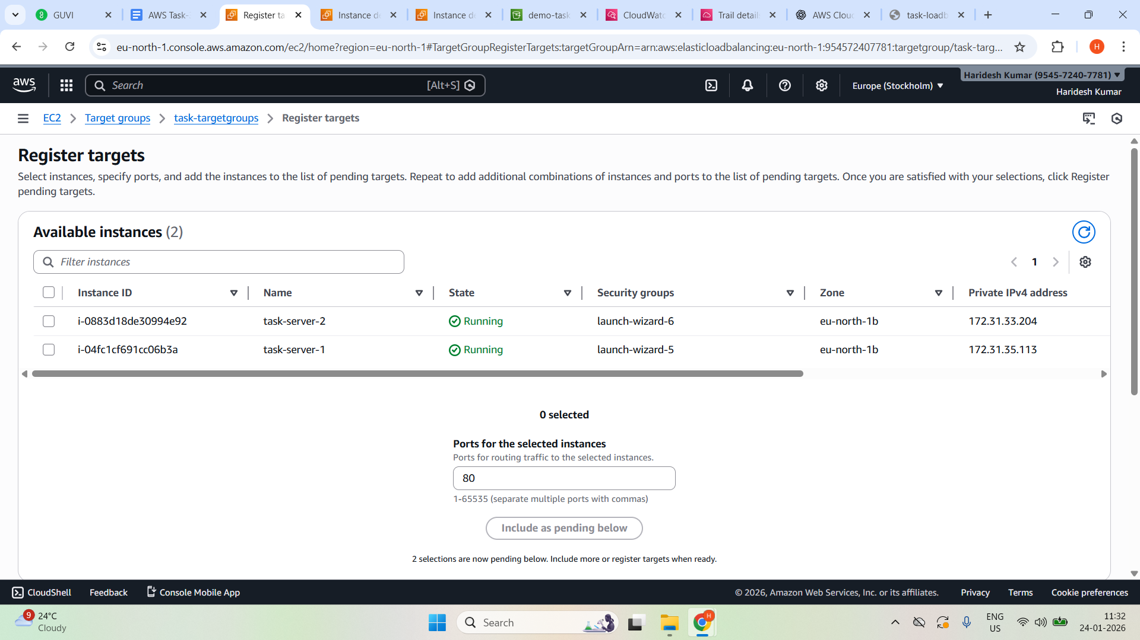

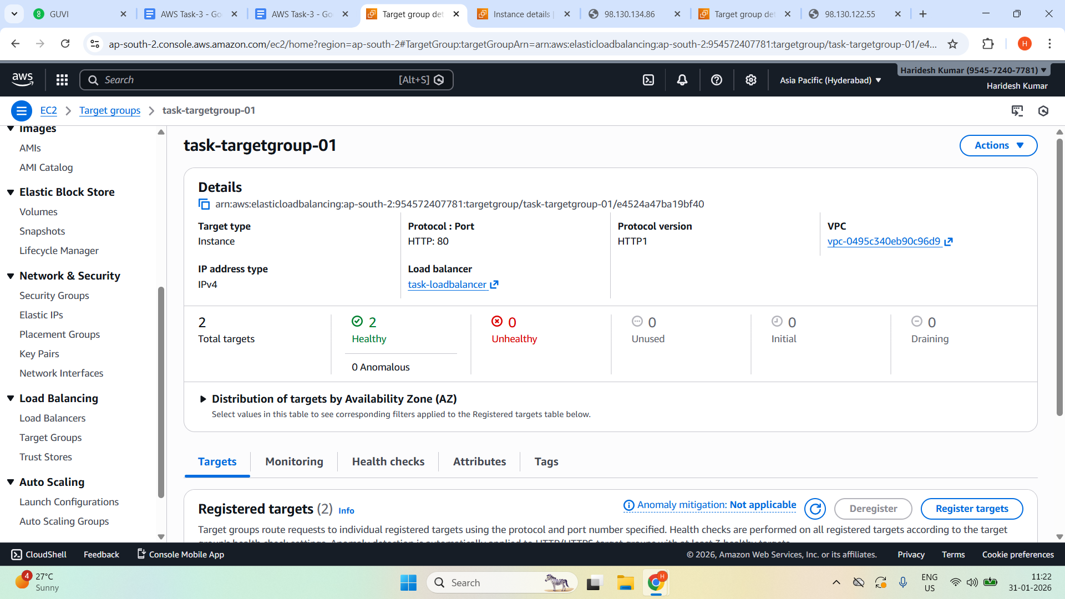

Create Application Load Balancer

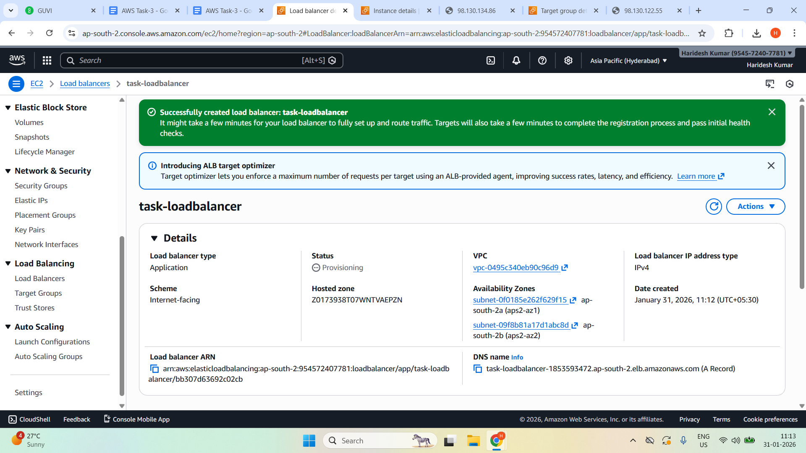

Active Status

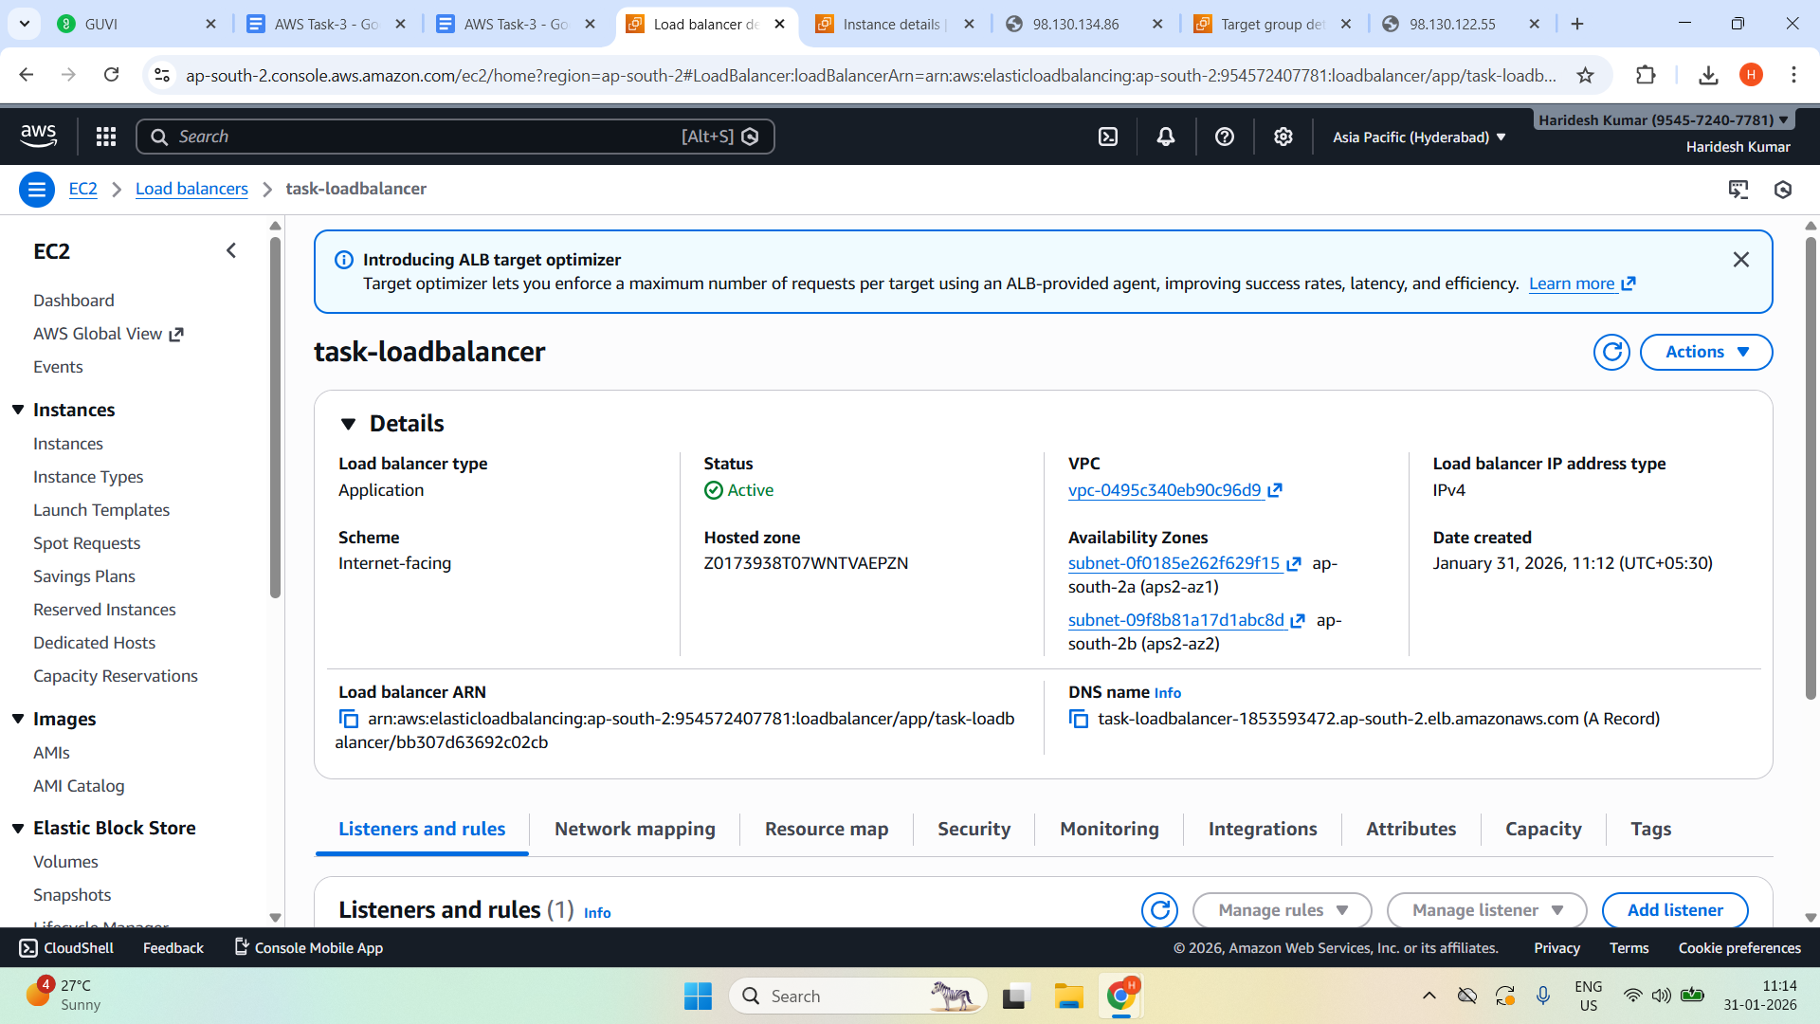

Edit Rules in the Listeners and rules.

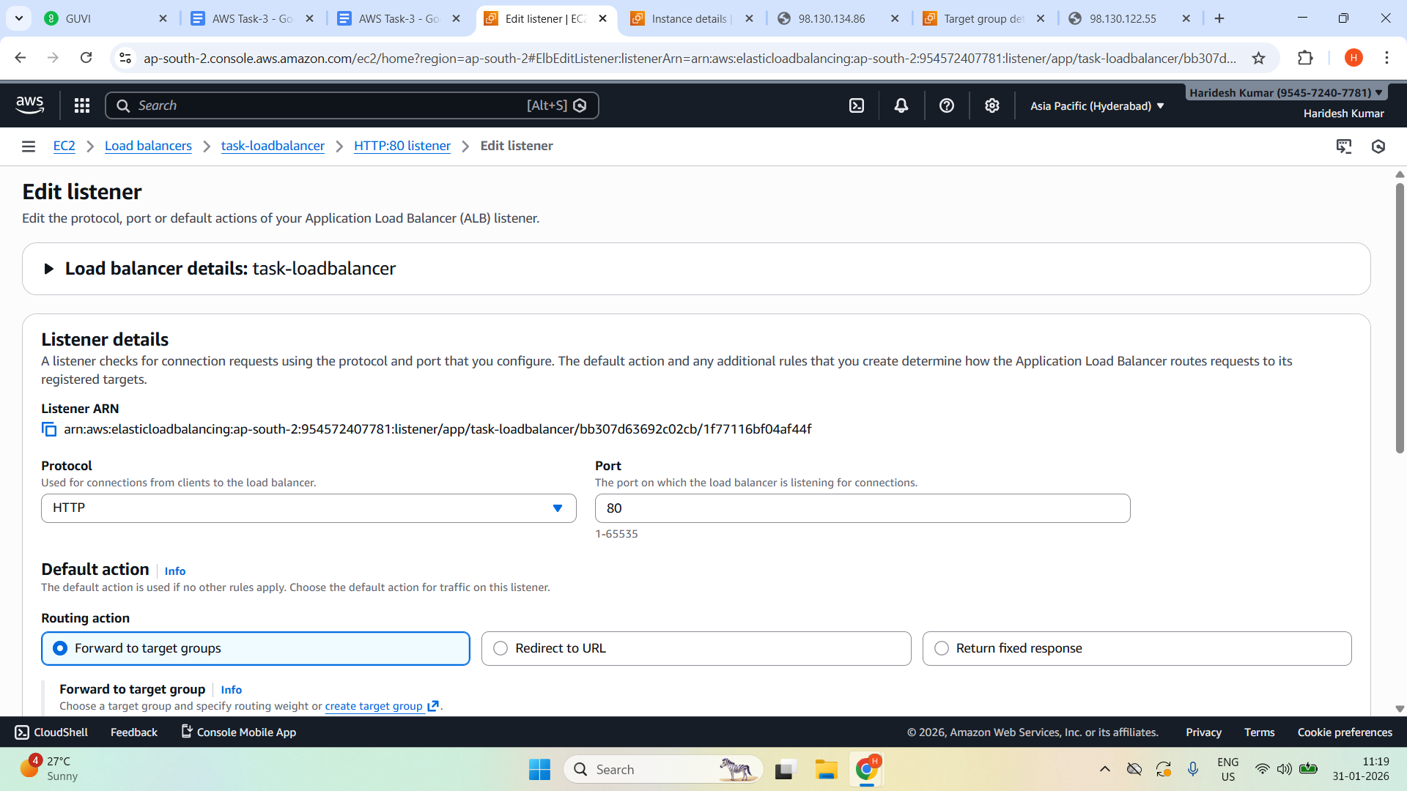

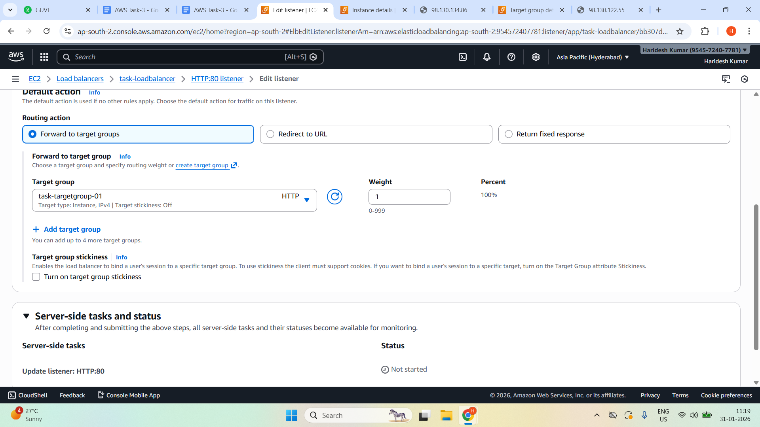

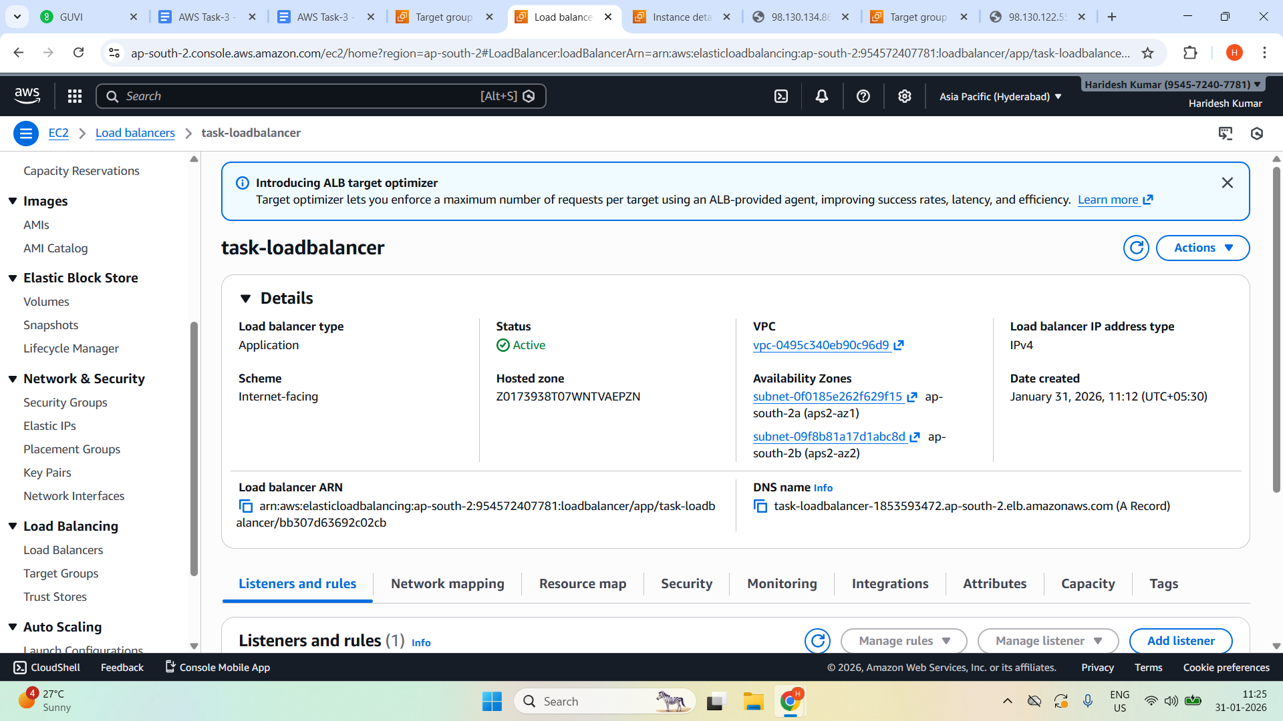

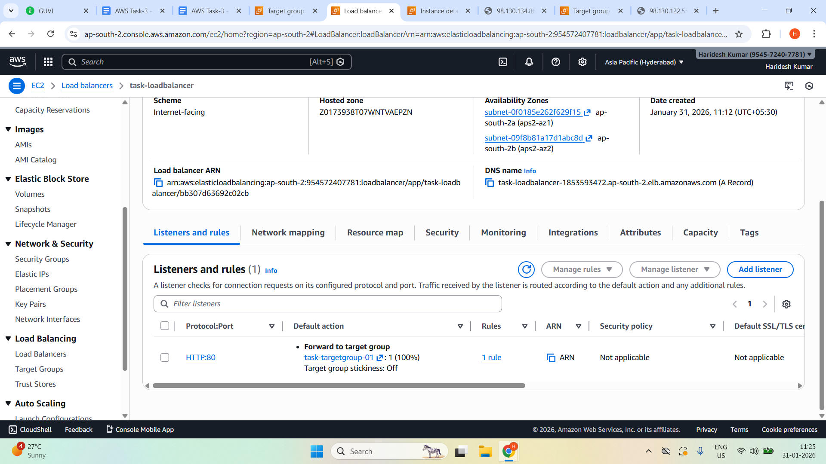

Once created the Load balancer. Have to wait for a health check. It should be shown now **healthy: 2 in the target group**

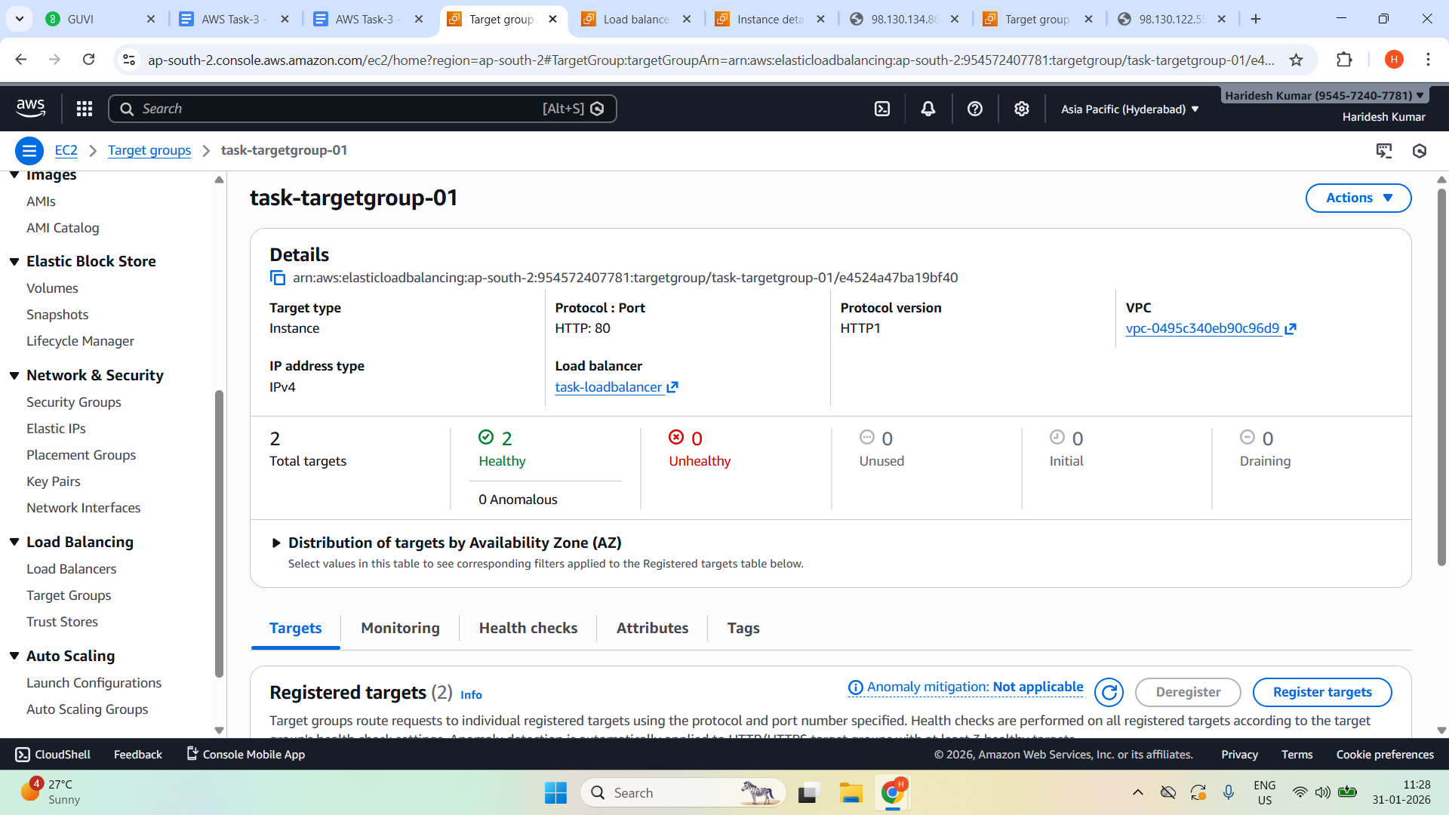

Copy DNS name of the Load Balancer

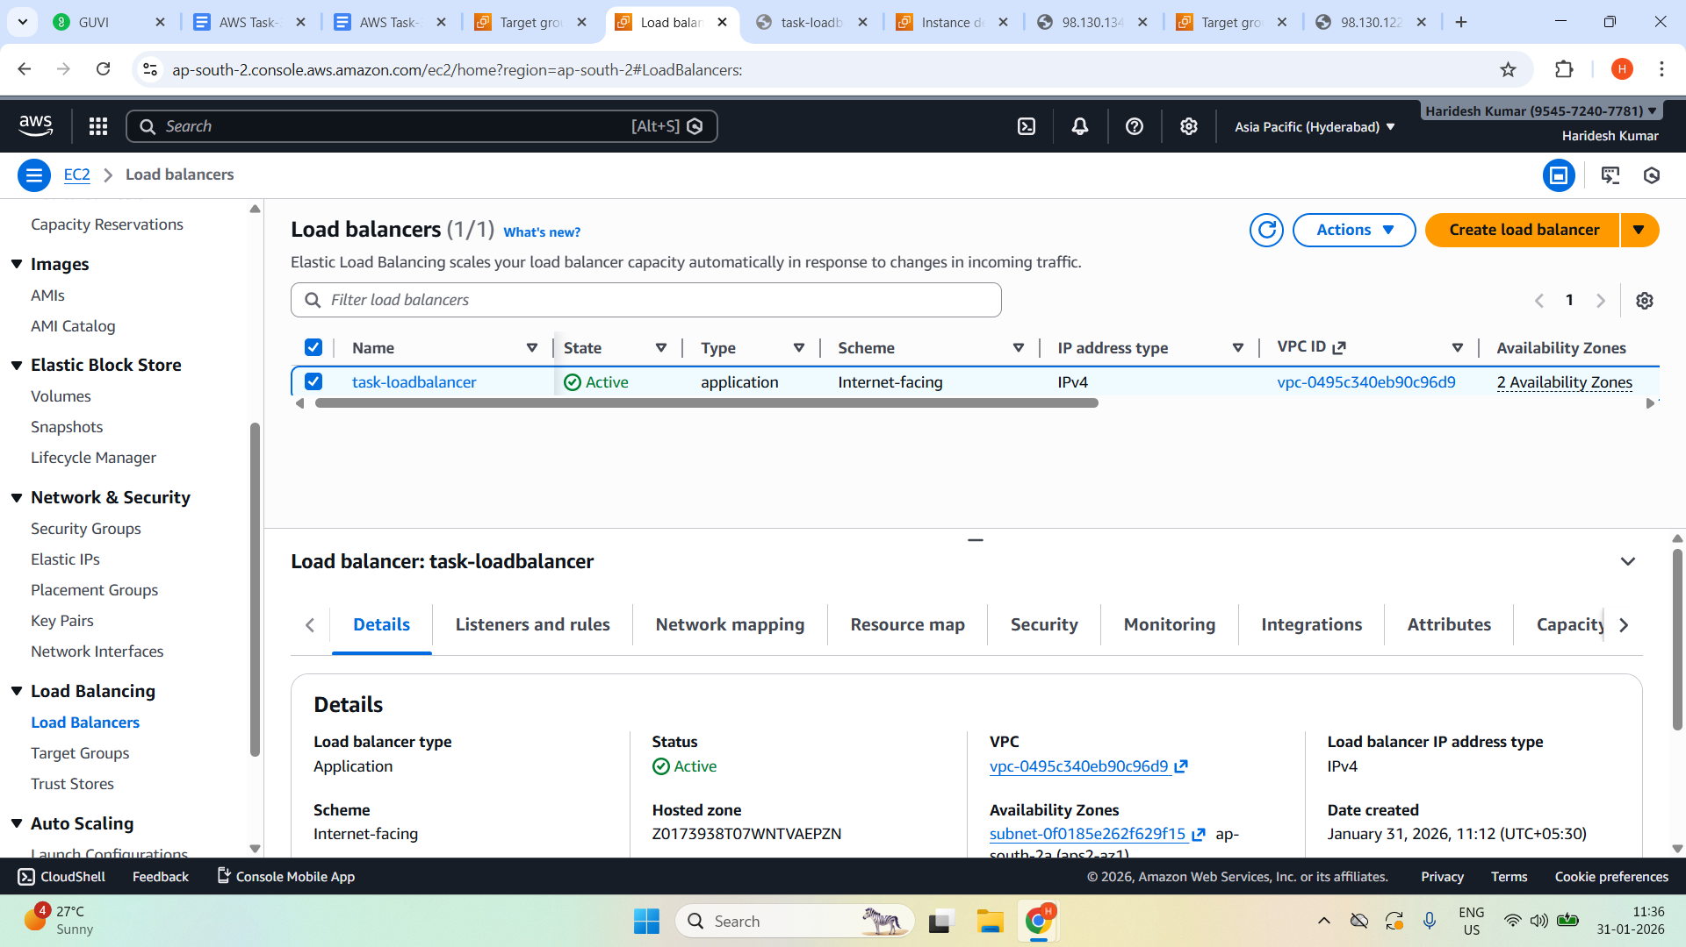

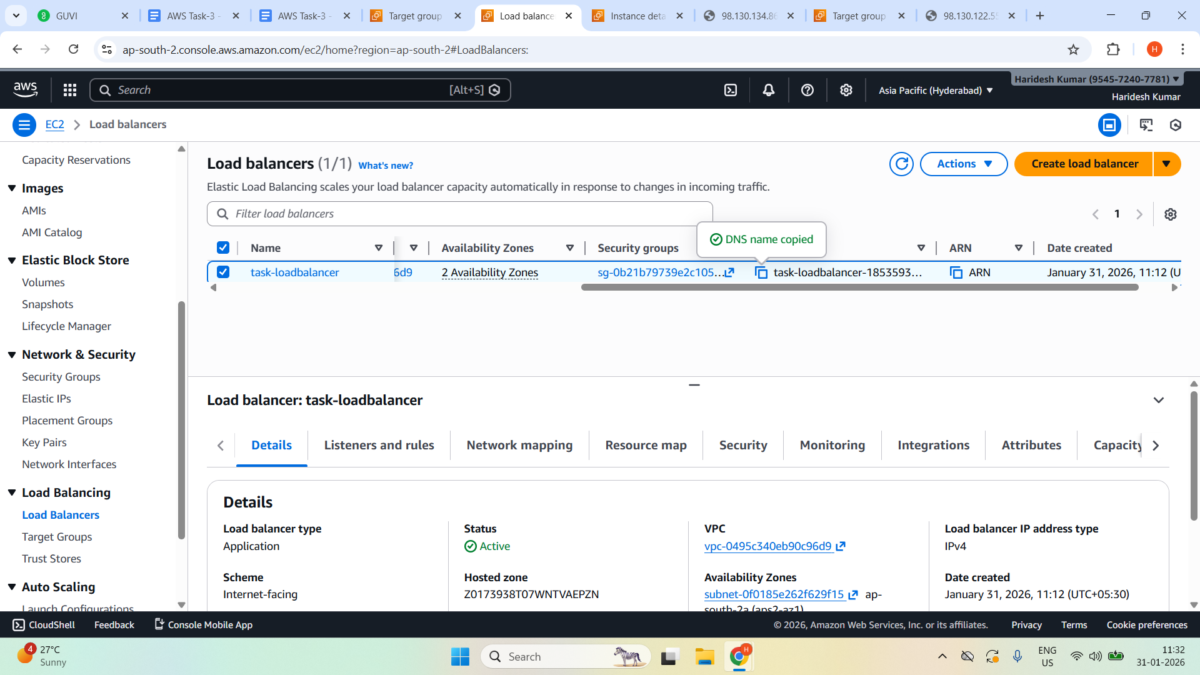

Open **Load Balancer DNS** in browser:

http://<your-load-balancer-dns>

<http://task-loadbalancer-1853593472.ap-south-2.elb.amazonaws.com>

Can’t able to access

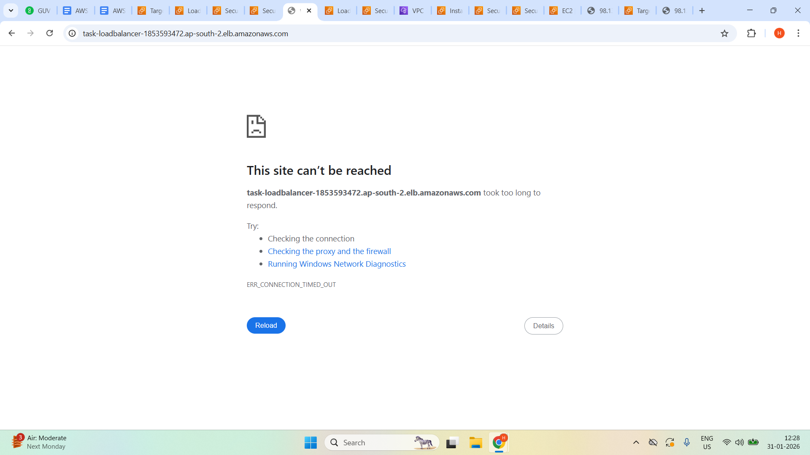

Create security group

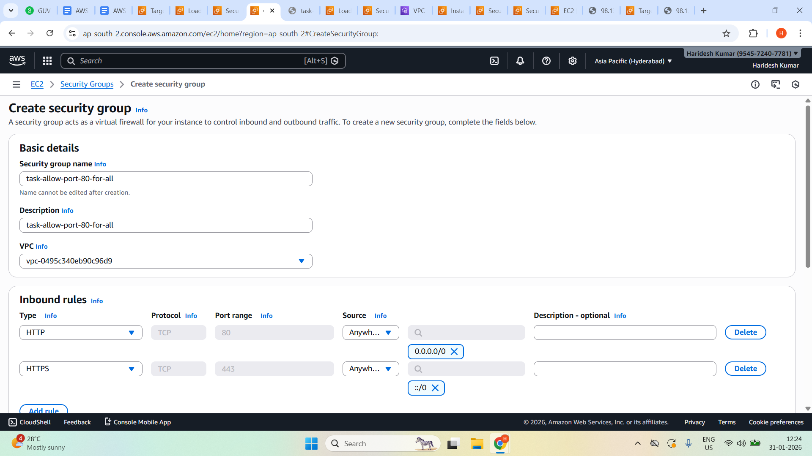

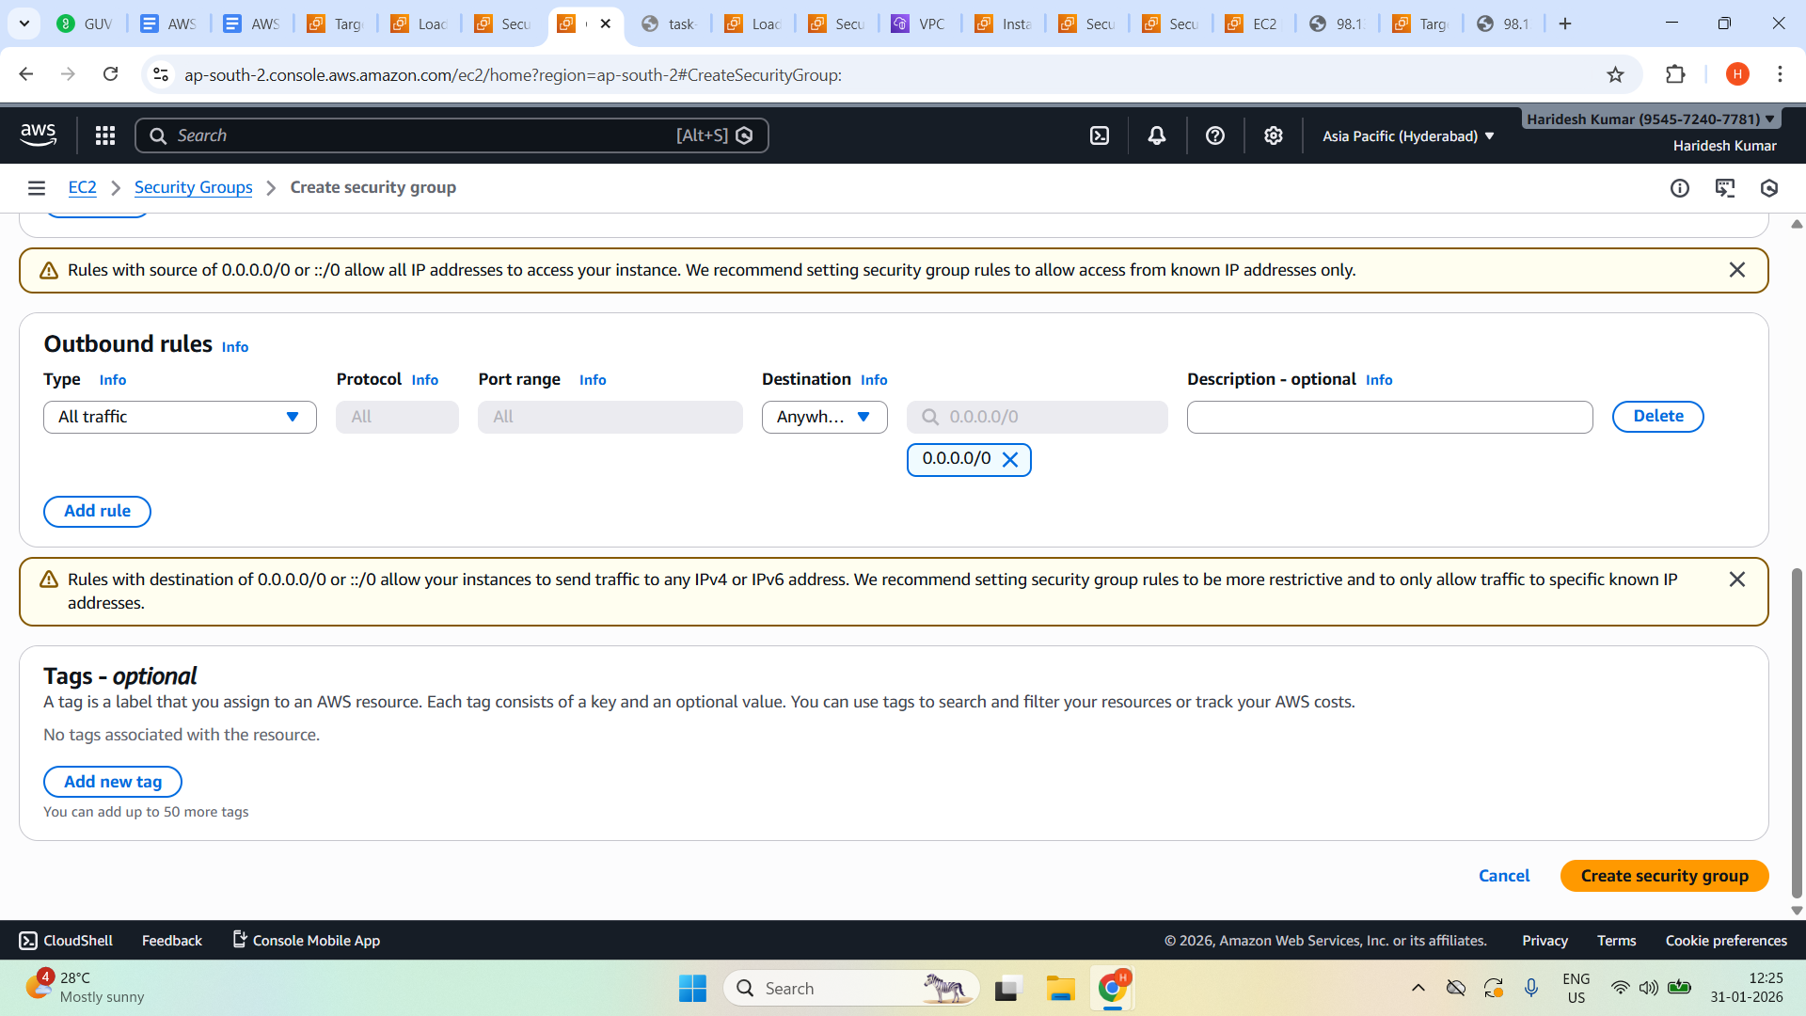

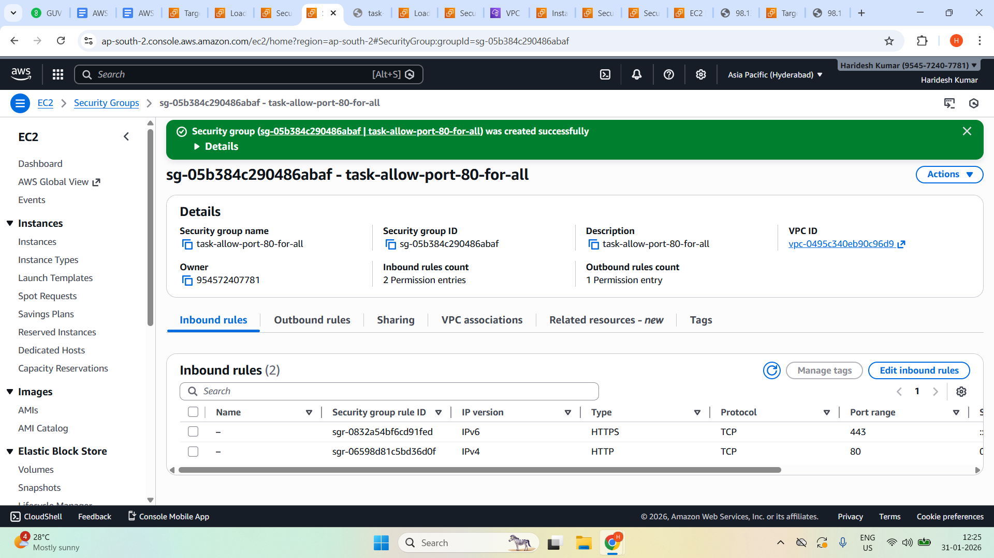

Edit the security group to remove default SG and save with new SG which is created.

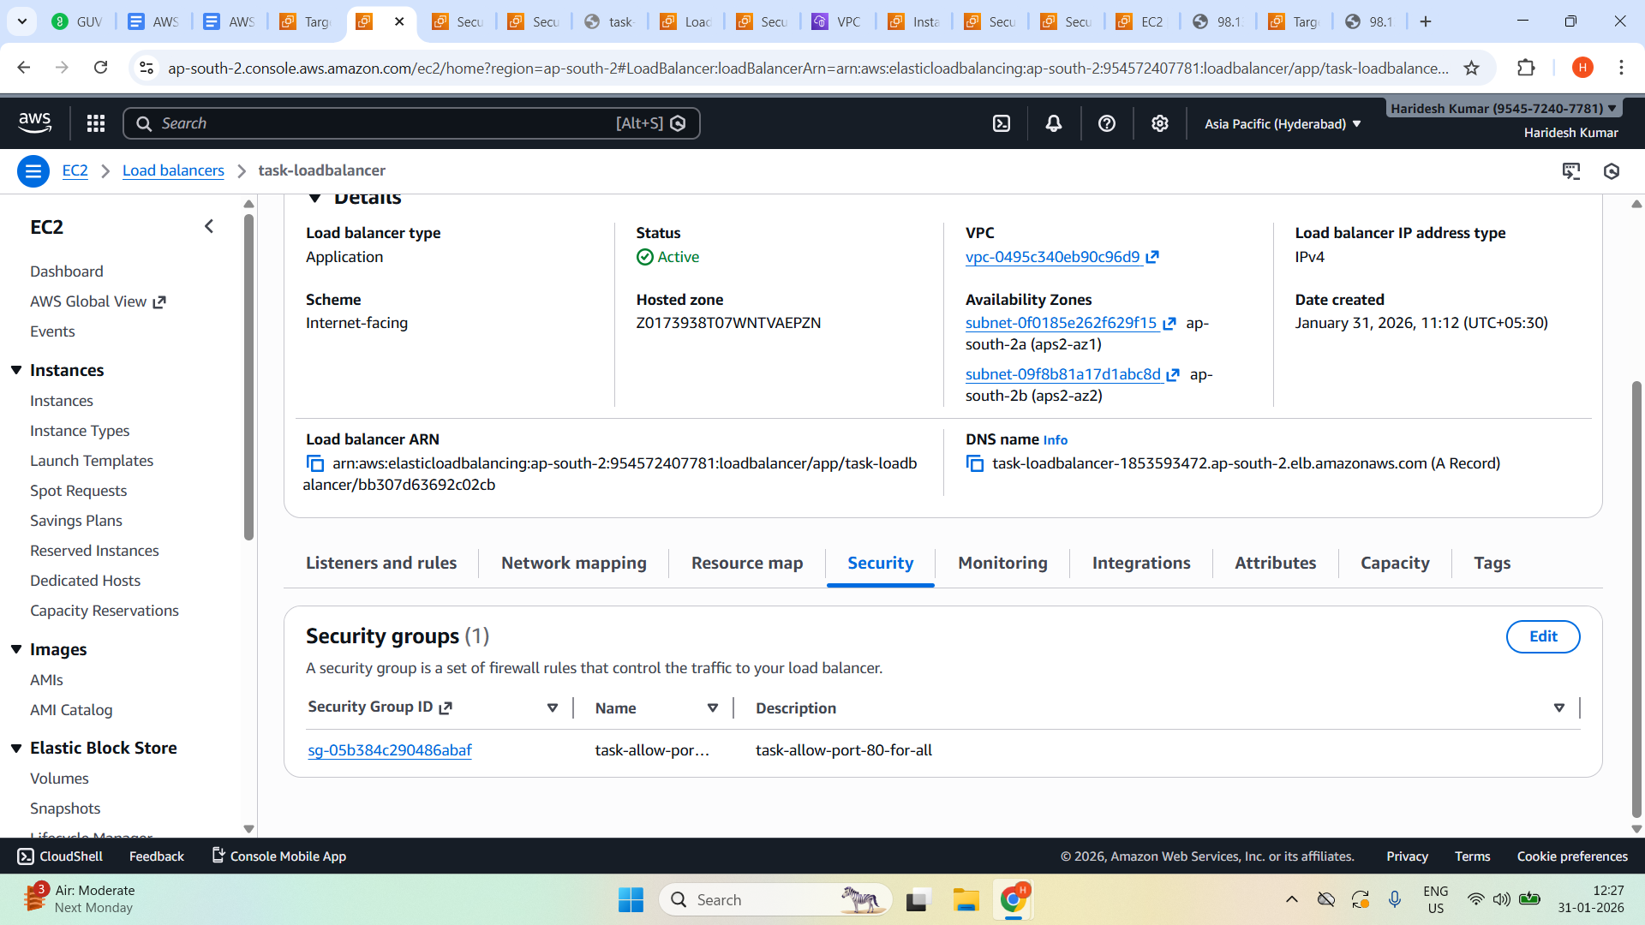

Again open the Load Balancer DNS name in browser.

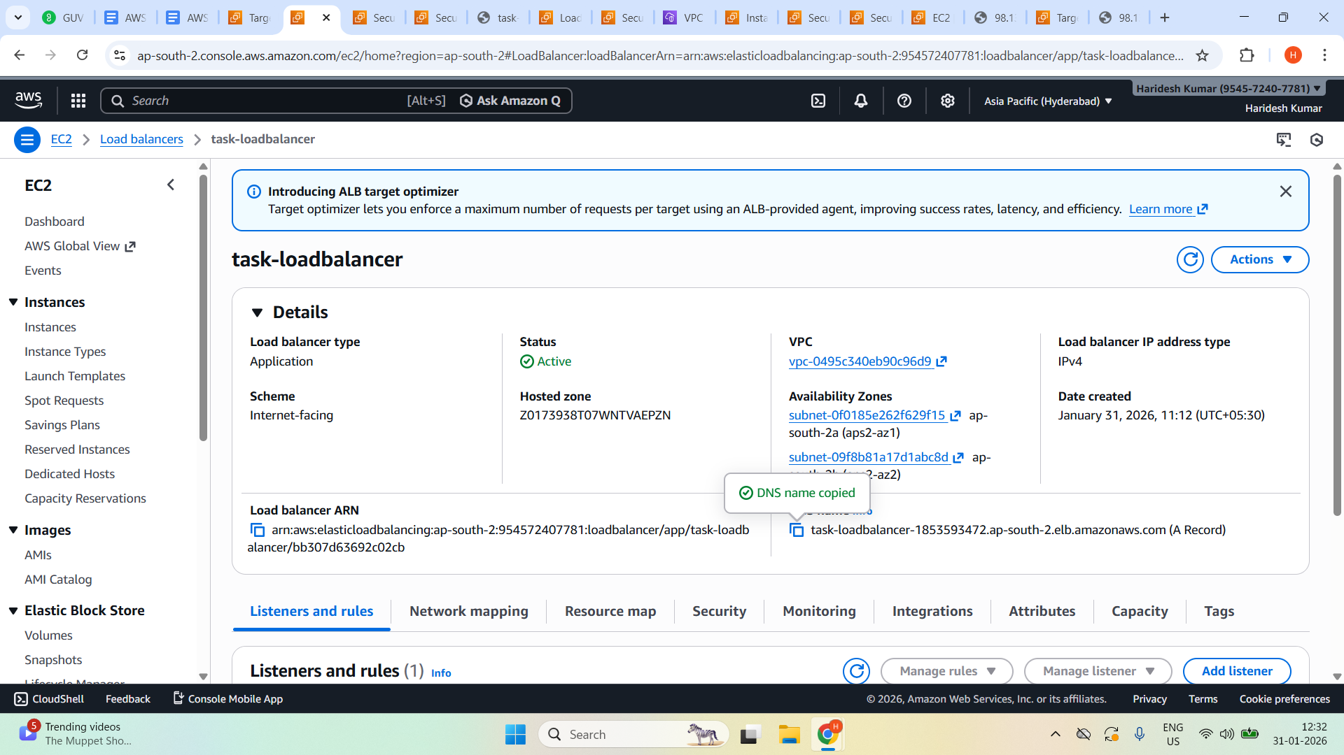

[task-loadbalancer-1853593472.ap-south-2.elb.amazonaws.com](http://task-loadbalancer-1853593472.ap-south-2.elb.amazonaws.com)

